**IFT 458: MIDDLEWARE PROG & DATABASE SEC (2022 FALL)**

AMBUK REHANI

Module 4 Activity 4: Create Requirements and transfer the requirement to Entity Design using UML

DINESH STHAPIT

SUNDAY OCT 8 BY 11:59 PM

**Step 1**: **Git Link:**

<https://github.com/harshalyeole/544-M4A4>

**Part 1: Requirements:**

**Update, alter or change the ERD diagram to meet the following requirement.**

**a) The entity for the Customer must have the following properties:**

* **ID**
* **NAME**
* **FIRST NAME**
* **MIDDLE NAME,**
* **LAST NAME**
* **DATE OF BIRTH**
* **GENDER**
* **CREATED DATE ( *for logging and auditing*)**
* **MODIFIED DATE( *for logging and auditing*)**
* **IS DELETED ( *for logging and auditing*)**

**b) The entity for the LOAN must have the following properties:**

* **ID**
* **LOAN_TYPE (Home, Auto, Boat, Life)**
* **LOAN NUMBER**
* **AMOUNT**
* **INTEREST_RATE**
* **LOAN_TERM( Years)**
* **START DATE**
* **CREATED DATE ( *for logging and auditing*)**
* **MODIFIED DATE( *for logging and auditing*)**
* **IS DELETED ( *for logging and auditing*)**

**c) The LOAN_LEDGER table**

* **ID**
* **PAYMENT_AMOUNT**
* **INTEREST**
* **PRINCIPAL**
* **CREATED DATE ( *for logging and auditing*)**
* **MODIFIED DATE( *for logging and auditing*)**
* **IS DELETED ( *for logging and auditing*)**

**You need to present a new ERD Diagram that meets all these requirements.**

**You also need to specify what data type you use to store these data.**



ER Diagram description:  
  
Customer Table: The Customer table includes attributes like name, date of birth, gender, and creation and modification dates, with _id serving as the primary key.

Loan Table: This table features loan-related attributes including type, number, loan amount, interest charged, and creation and modification dates, with _id acting as the primary key.

Loan_Ledger Table: Serving as a snapshot of customer payments toward their loans, this table incorporates two foreign keys from the Customer(_Id) and Loan(_Id) tables, referred to as CustomerID and LoanId respectively.

Customer to Loan_Ledger Mapping: A customer may correlate with zero to many entries (rows) in the Loan_Ledger table, whereas each entry in Loan_Ledger maintains a one-to-one relationship with a customer.

Loan to Loan_Ledger Mapping: A loan may associate with one to many entries (rows) in the Loan_Ledger table, while every Loan_Ledger entry adheres to a one-to-one association with a loan.

**Part 2: Requirement Storage Design Implementation: (DATABASE) (**Points 100)**

Create a new database in NoSQL MongoDB

DataBase Name: LOANS

Creates the MODELS as per your ERD Design

The following Attributes/Fields in all the tables must be auto-populated:

* ID ( IDENTITY)
* CREATED DATE ( ***for logging and auditing***) Default (CURRENT DATE or SQL GETDATA())
* MODIFIED DATE( ***for logging and auditing***). Default (CURRENT DATE or SQL GETDATA())

Insert Records for 10 Customers

Insert Records for 3 LoanTypes

Insert Records 2 Payments for 5 Customers with complete loan payments.

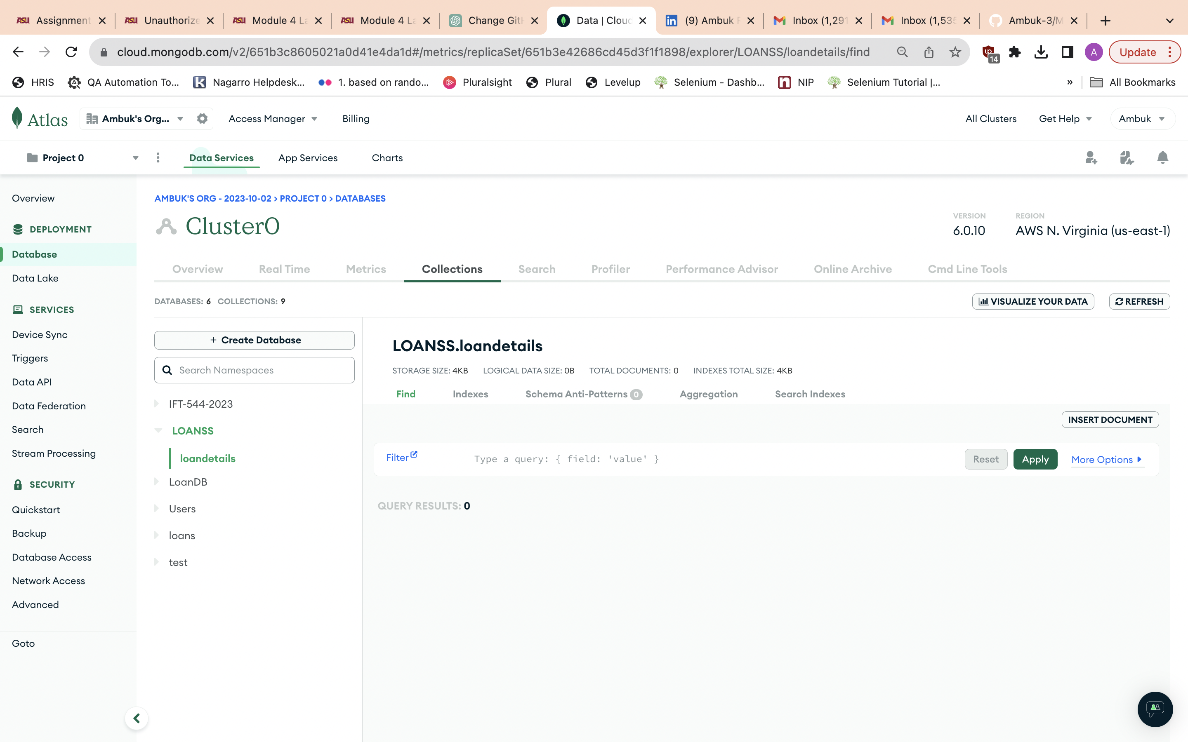

Code Screenshots:

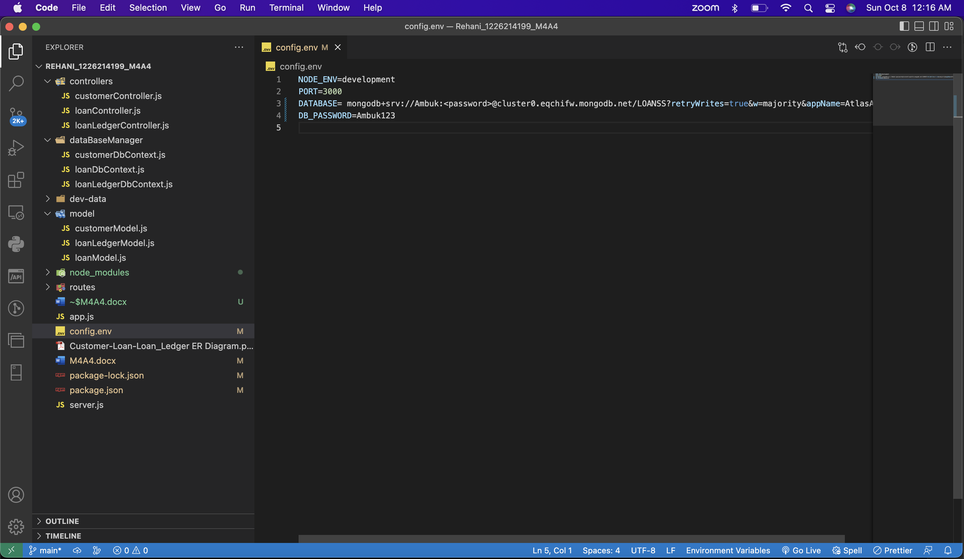

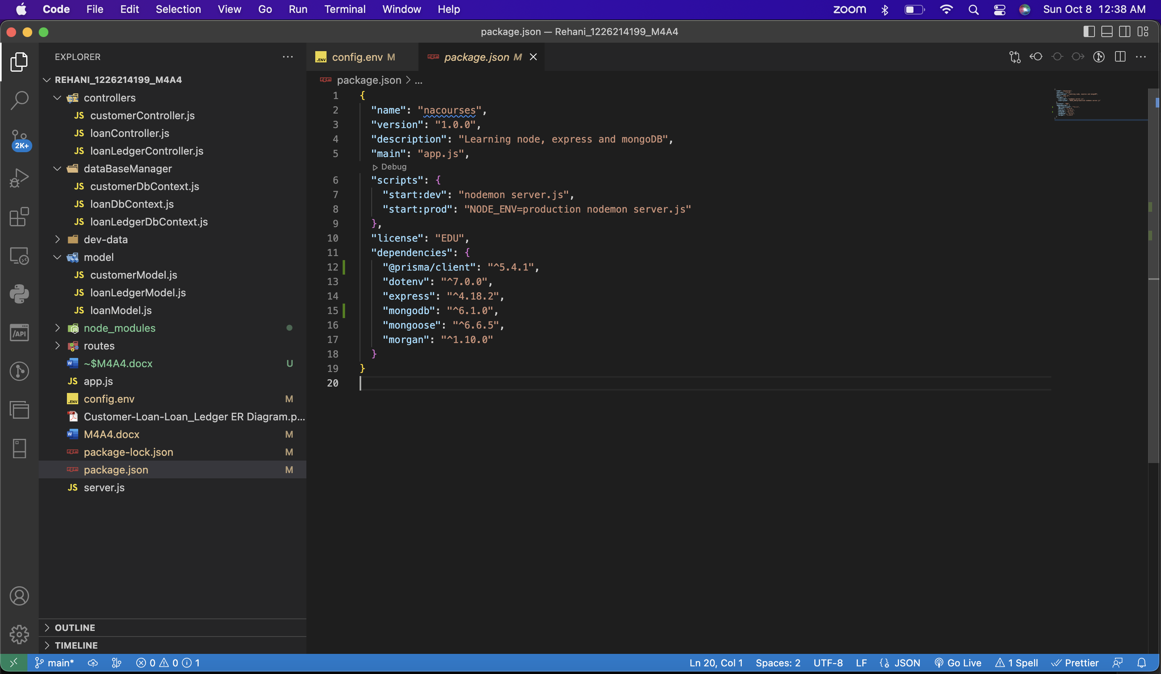

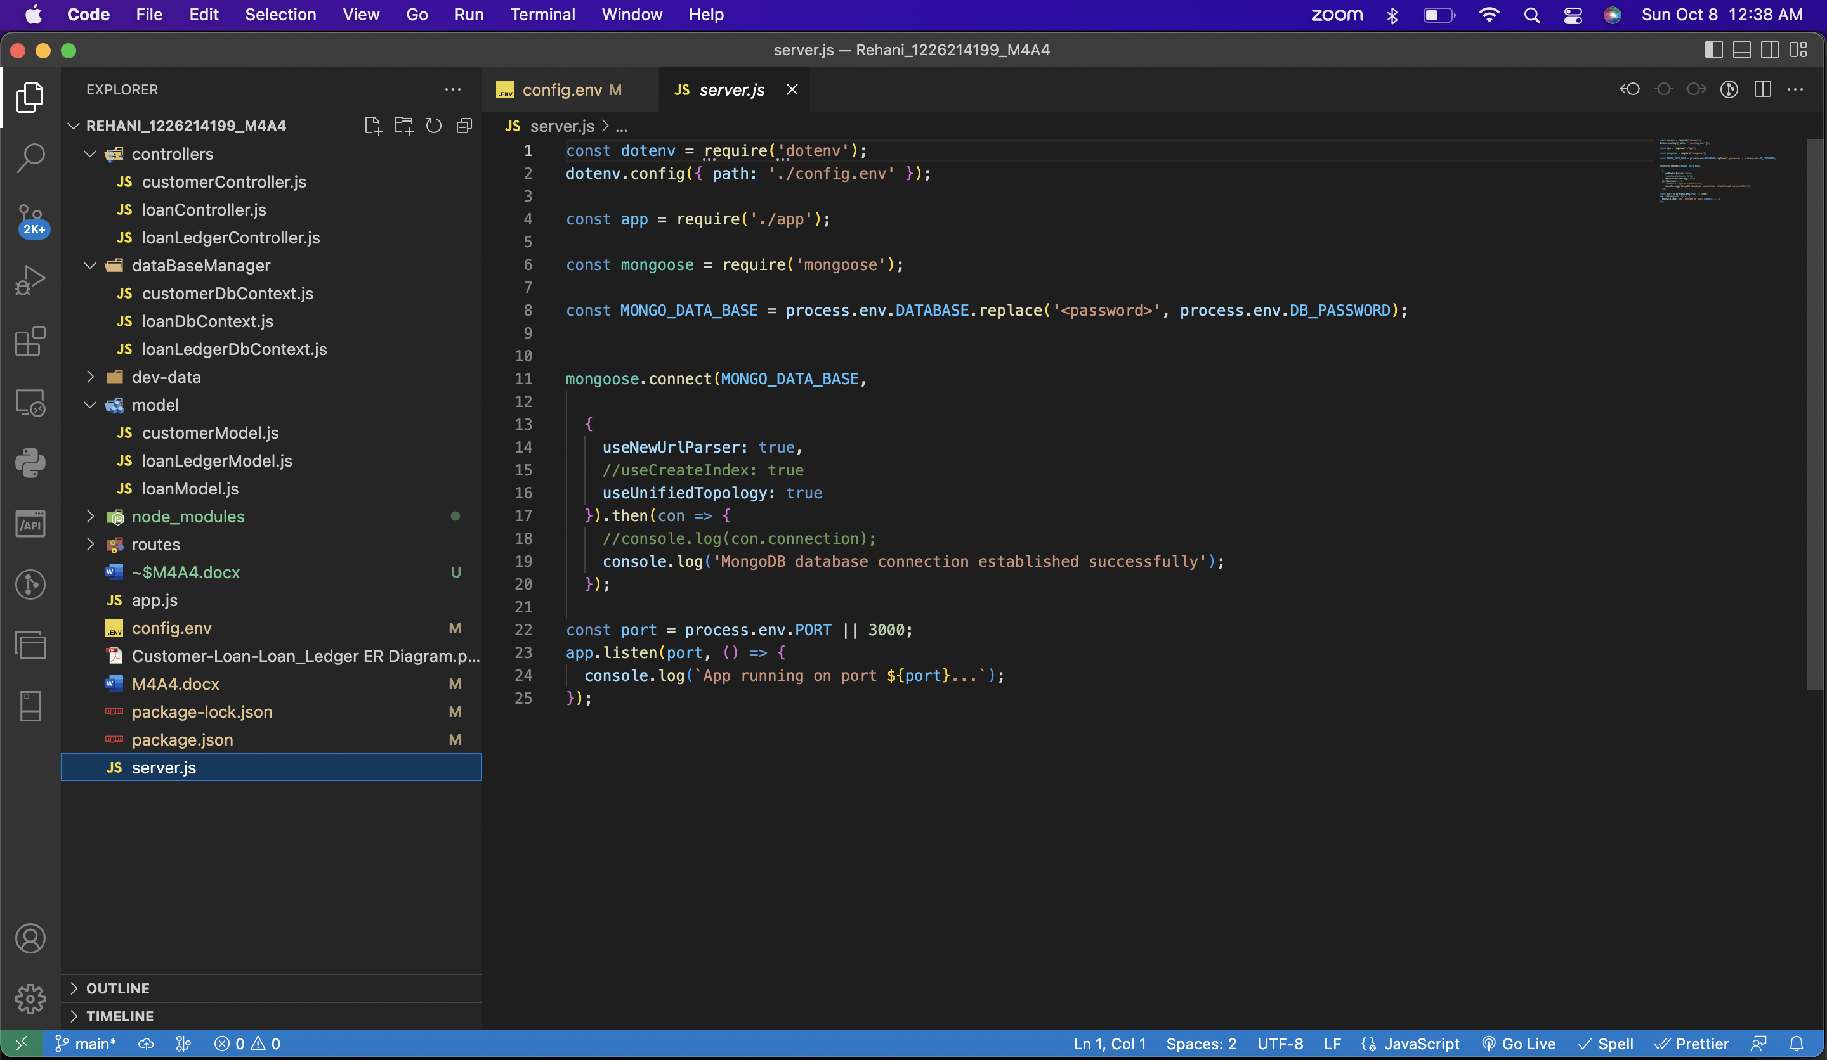

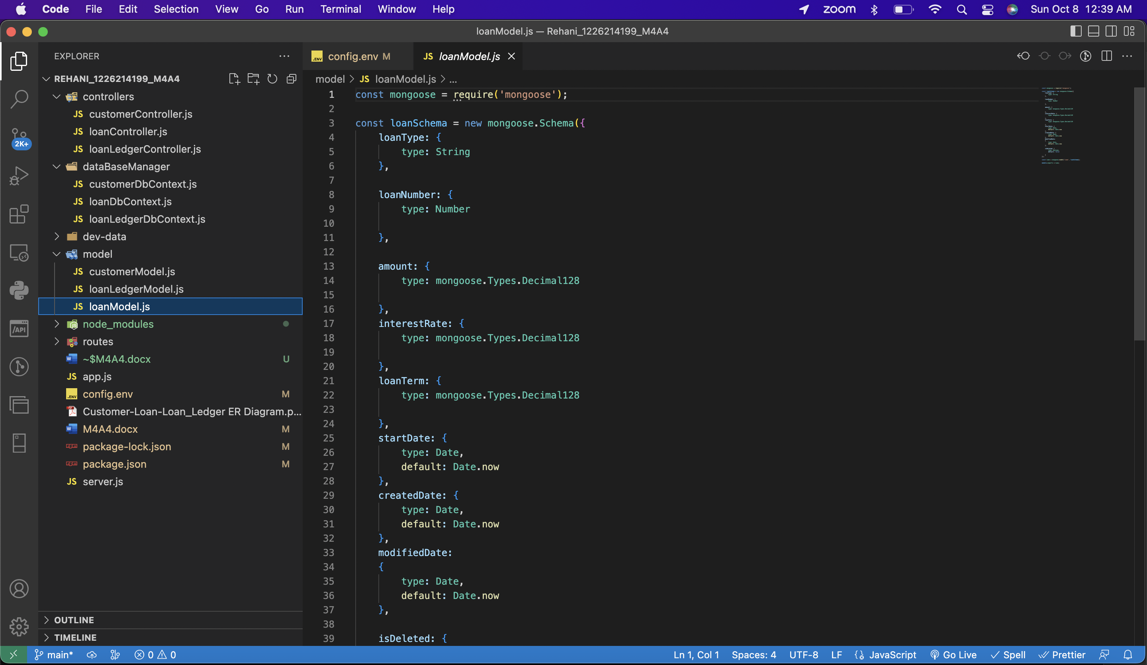

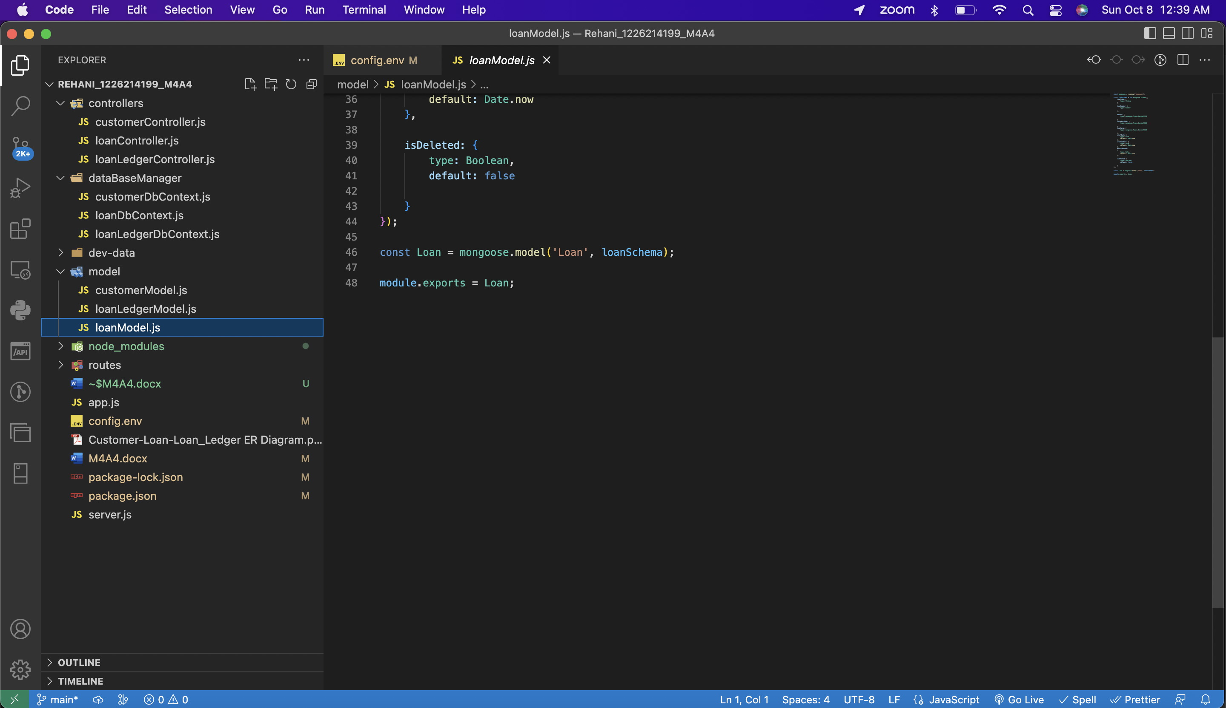

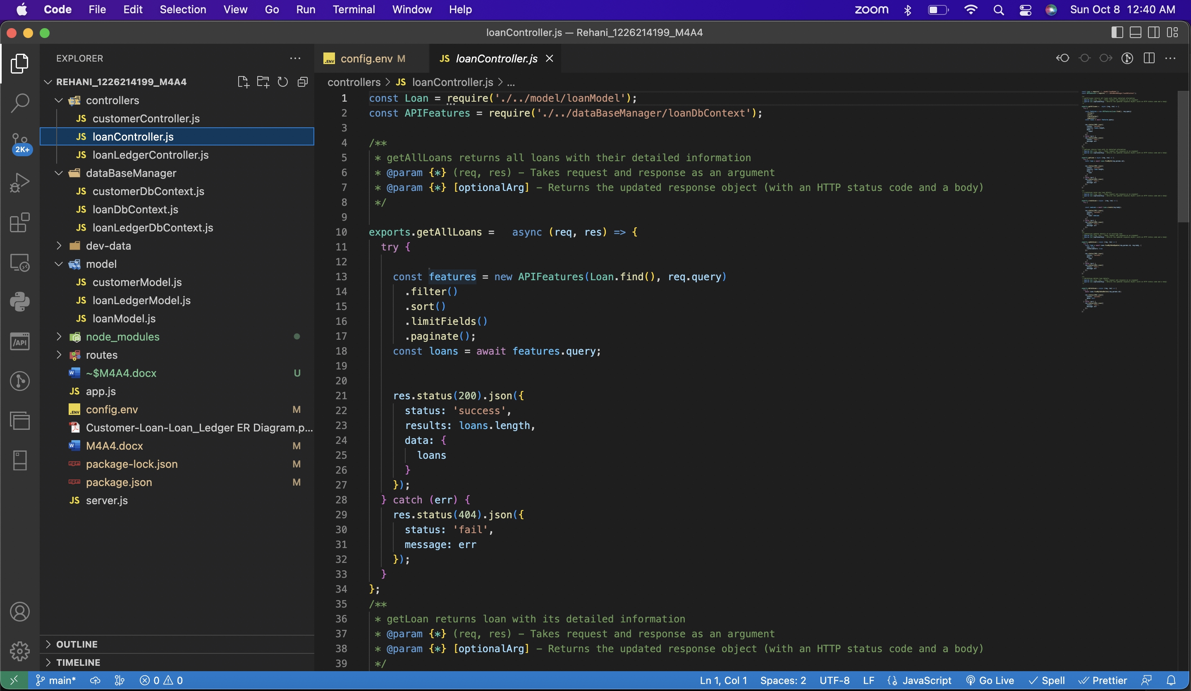

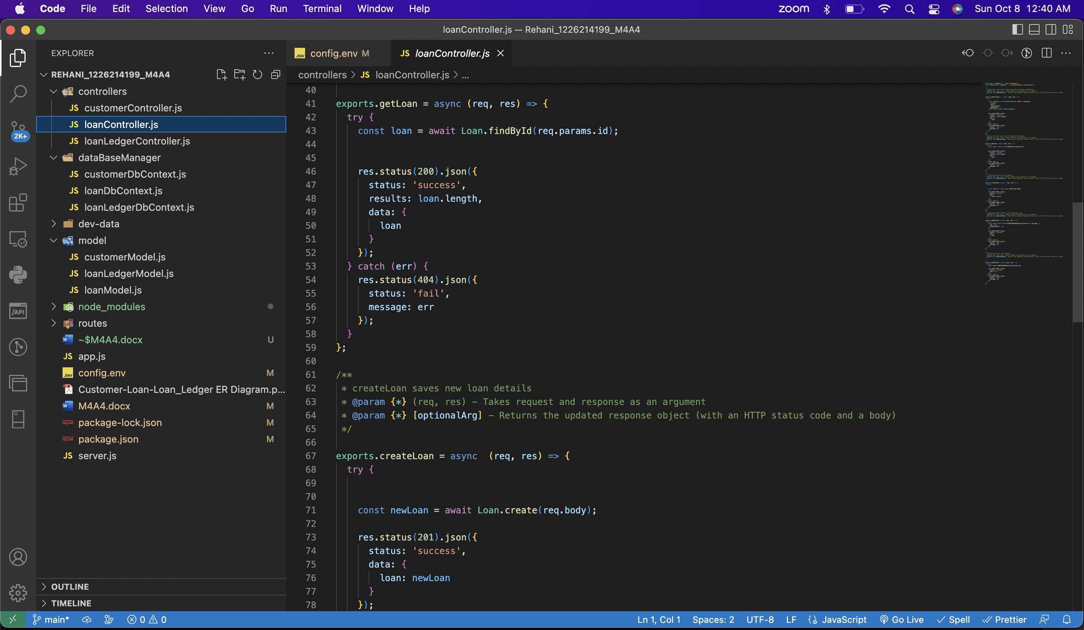

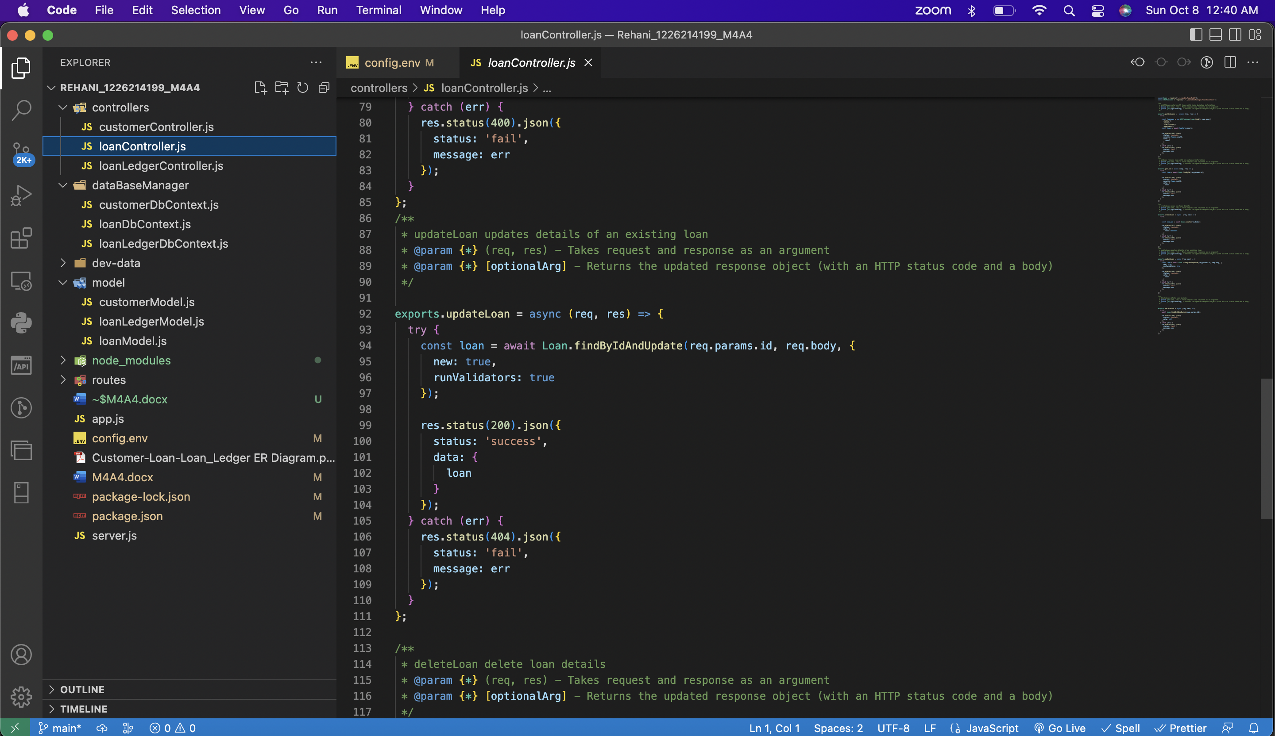

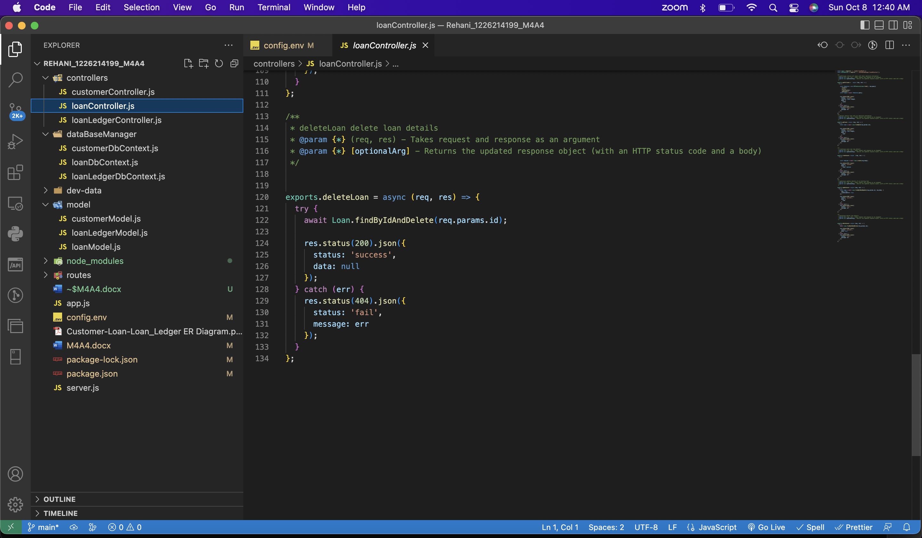

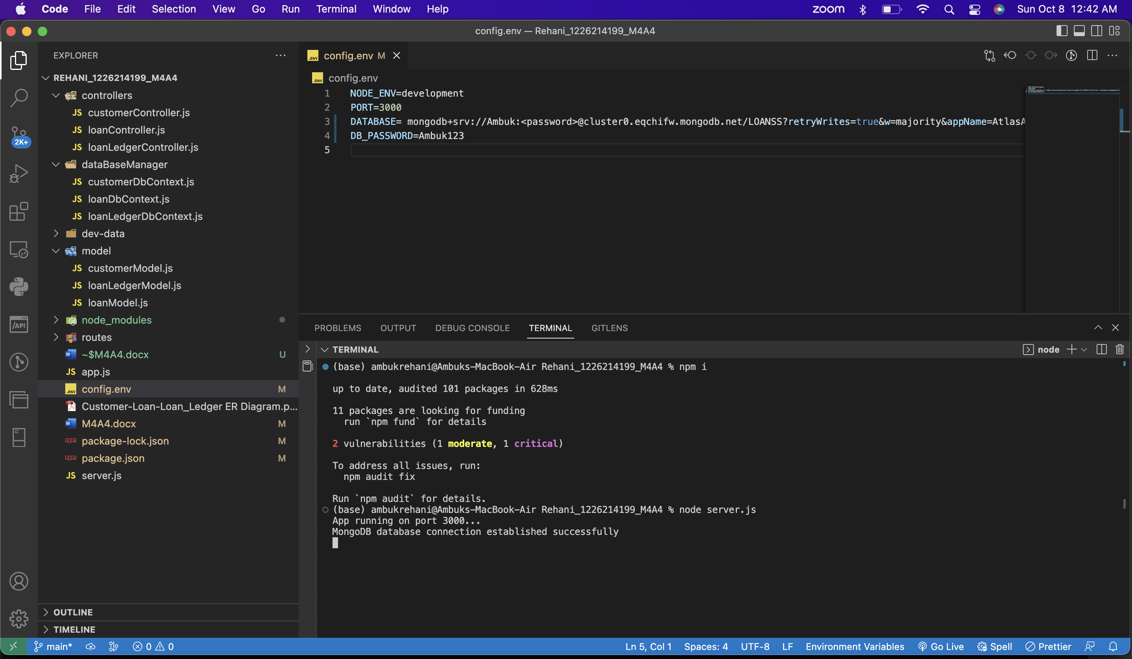

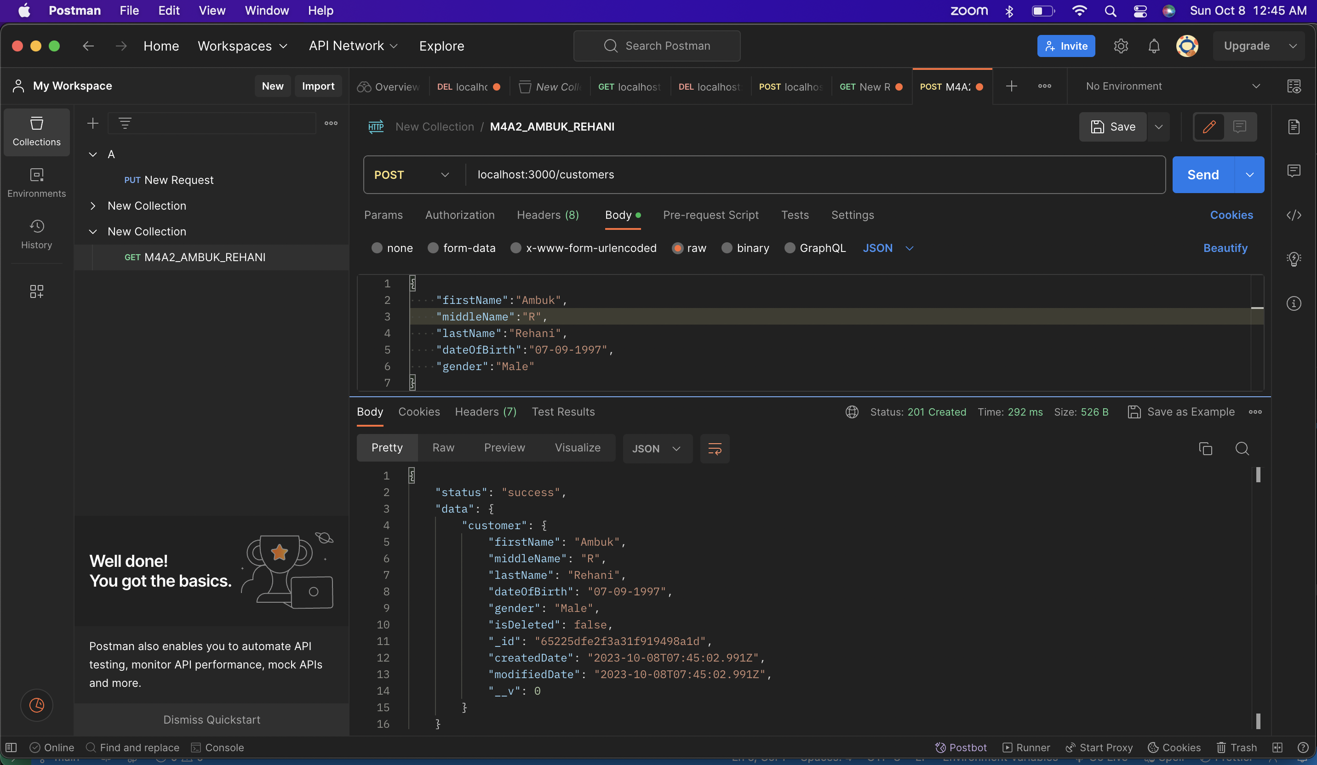

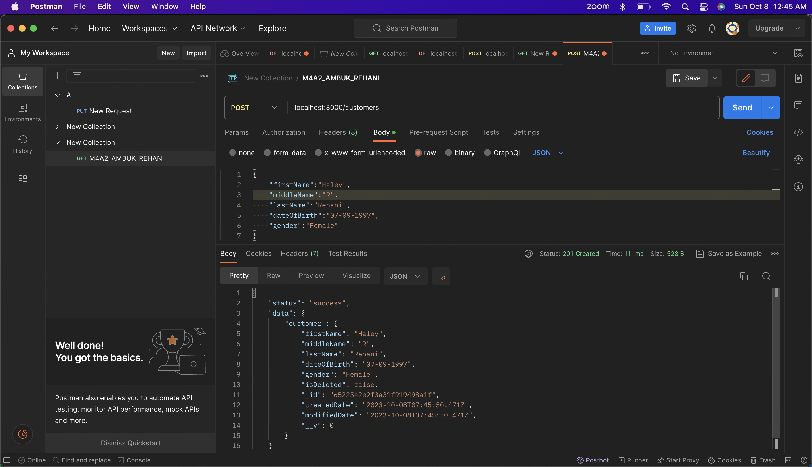

Multiple entries at a time:

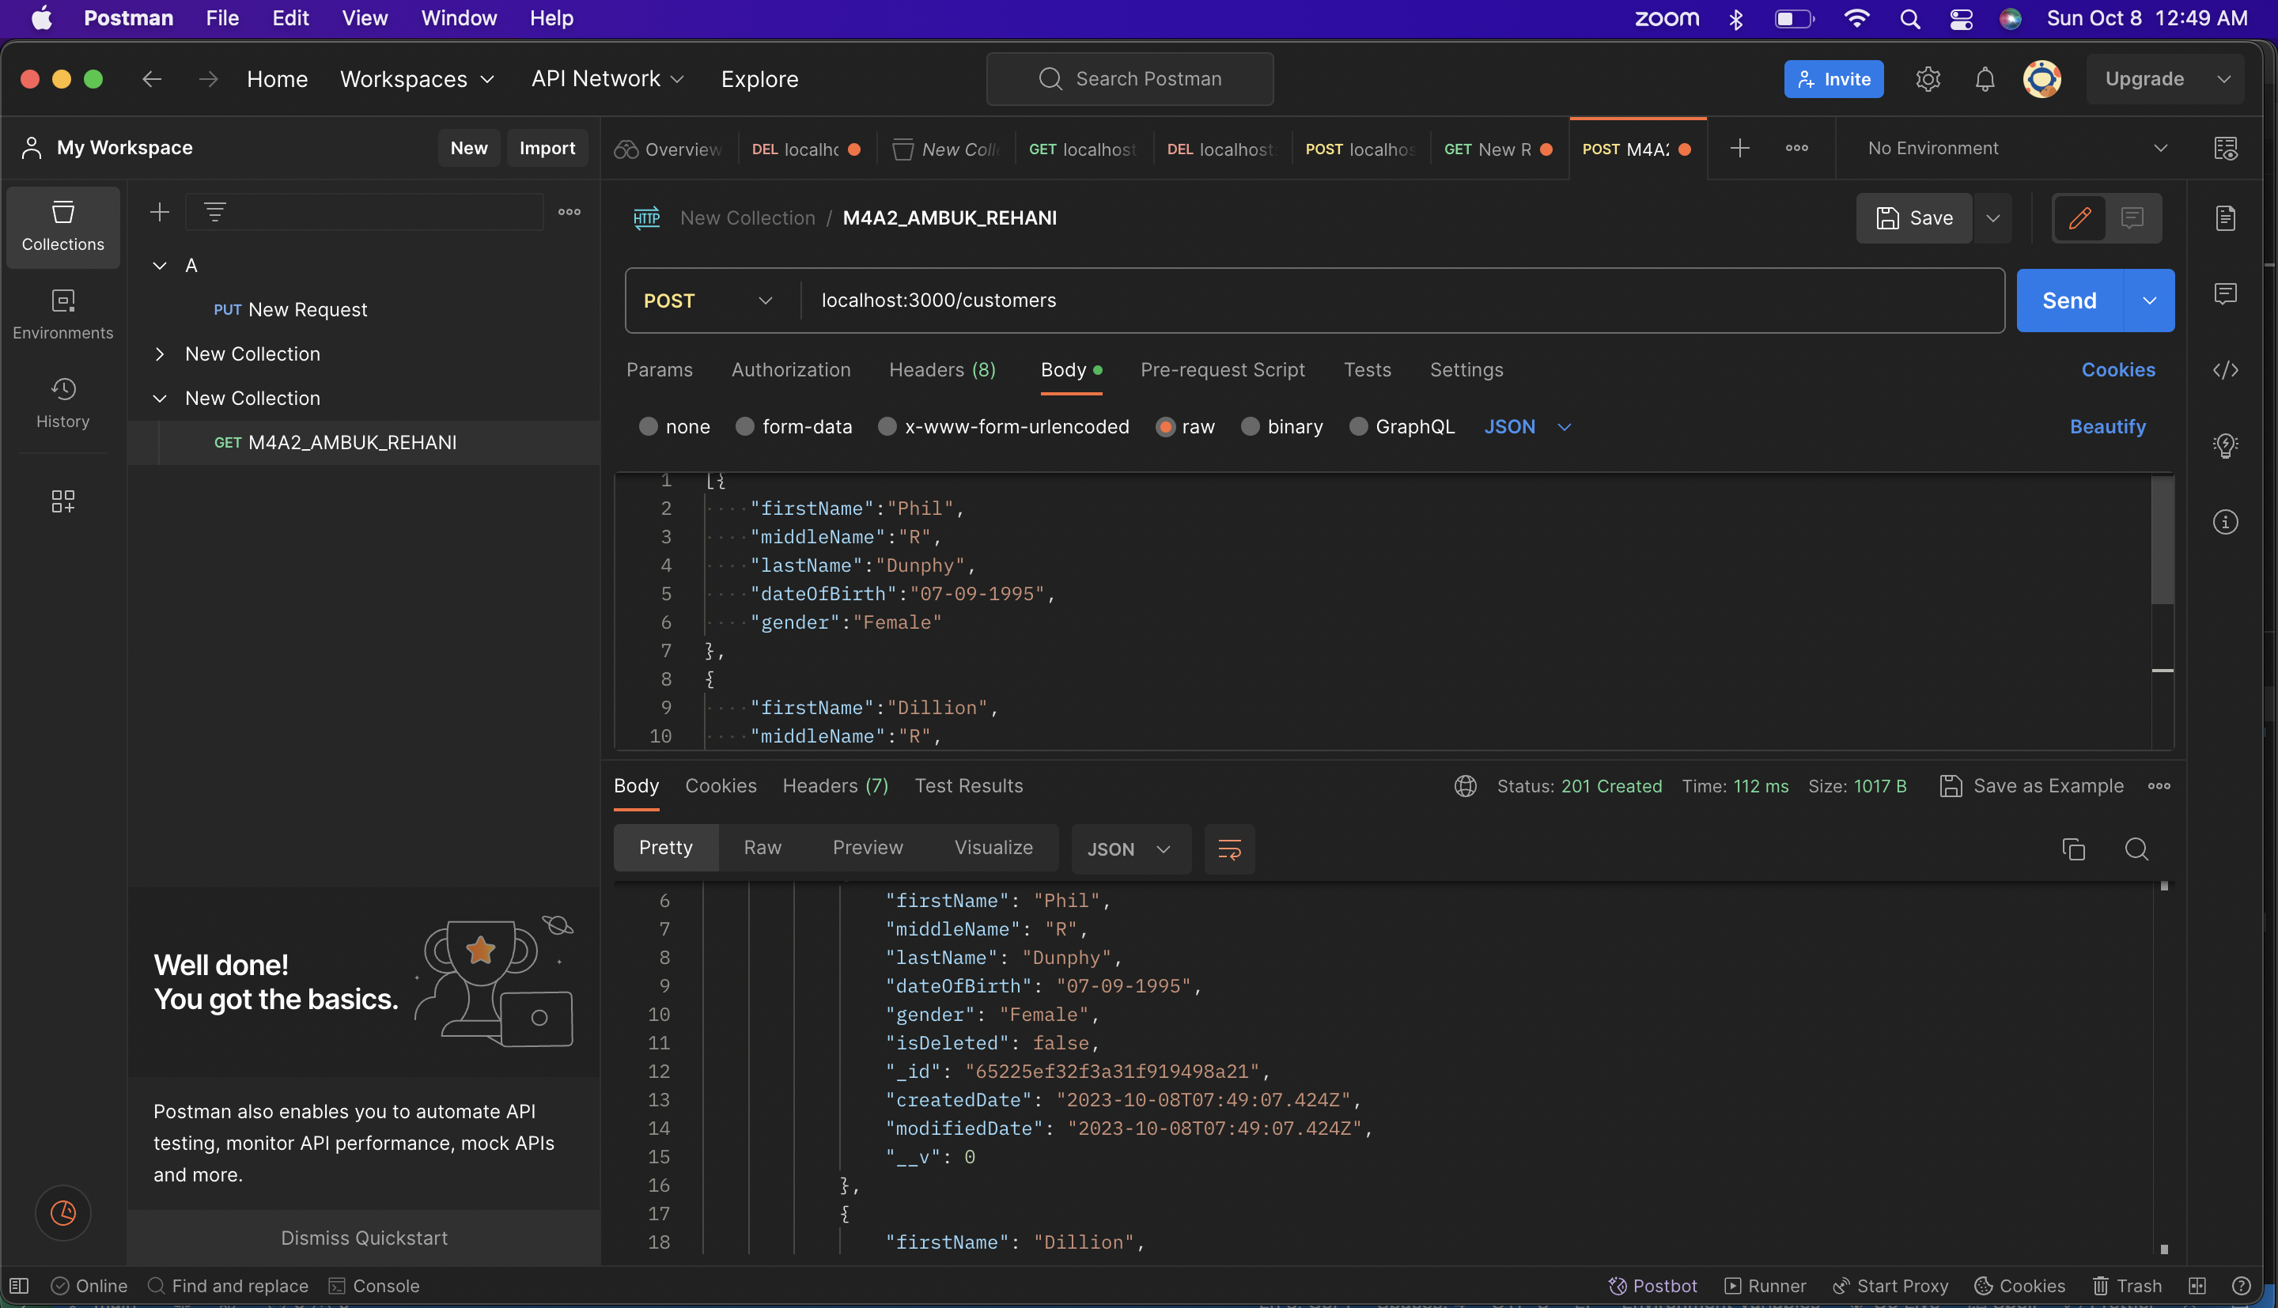

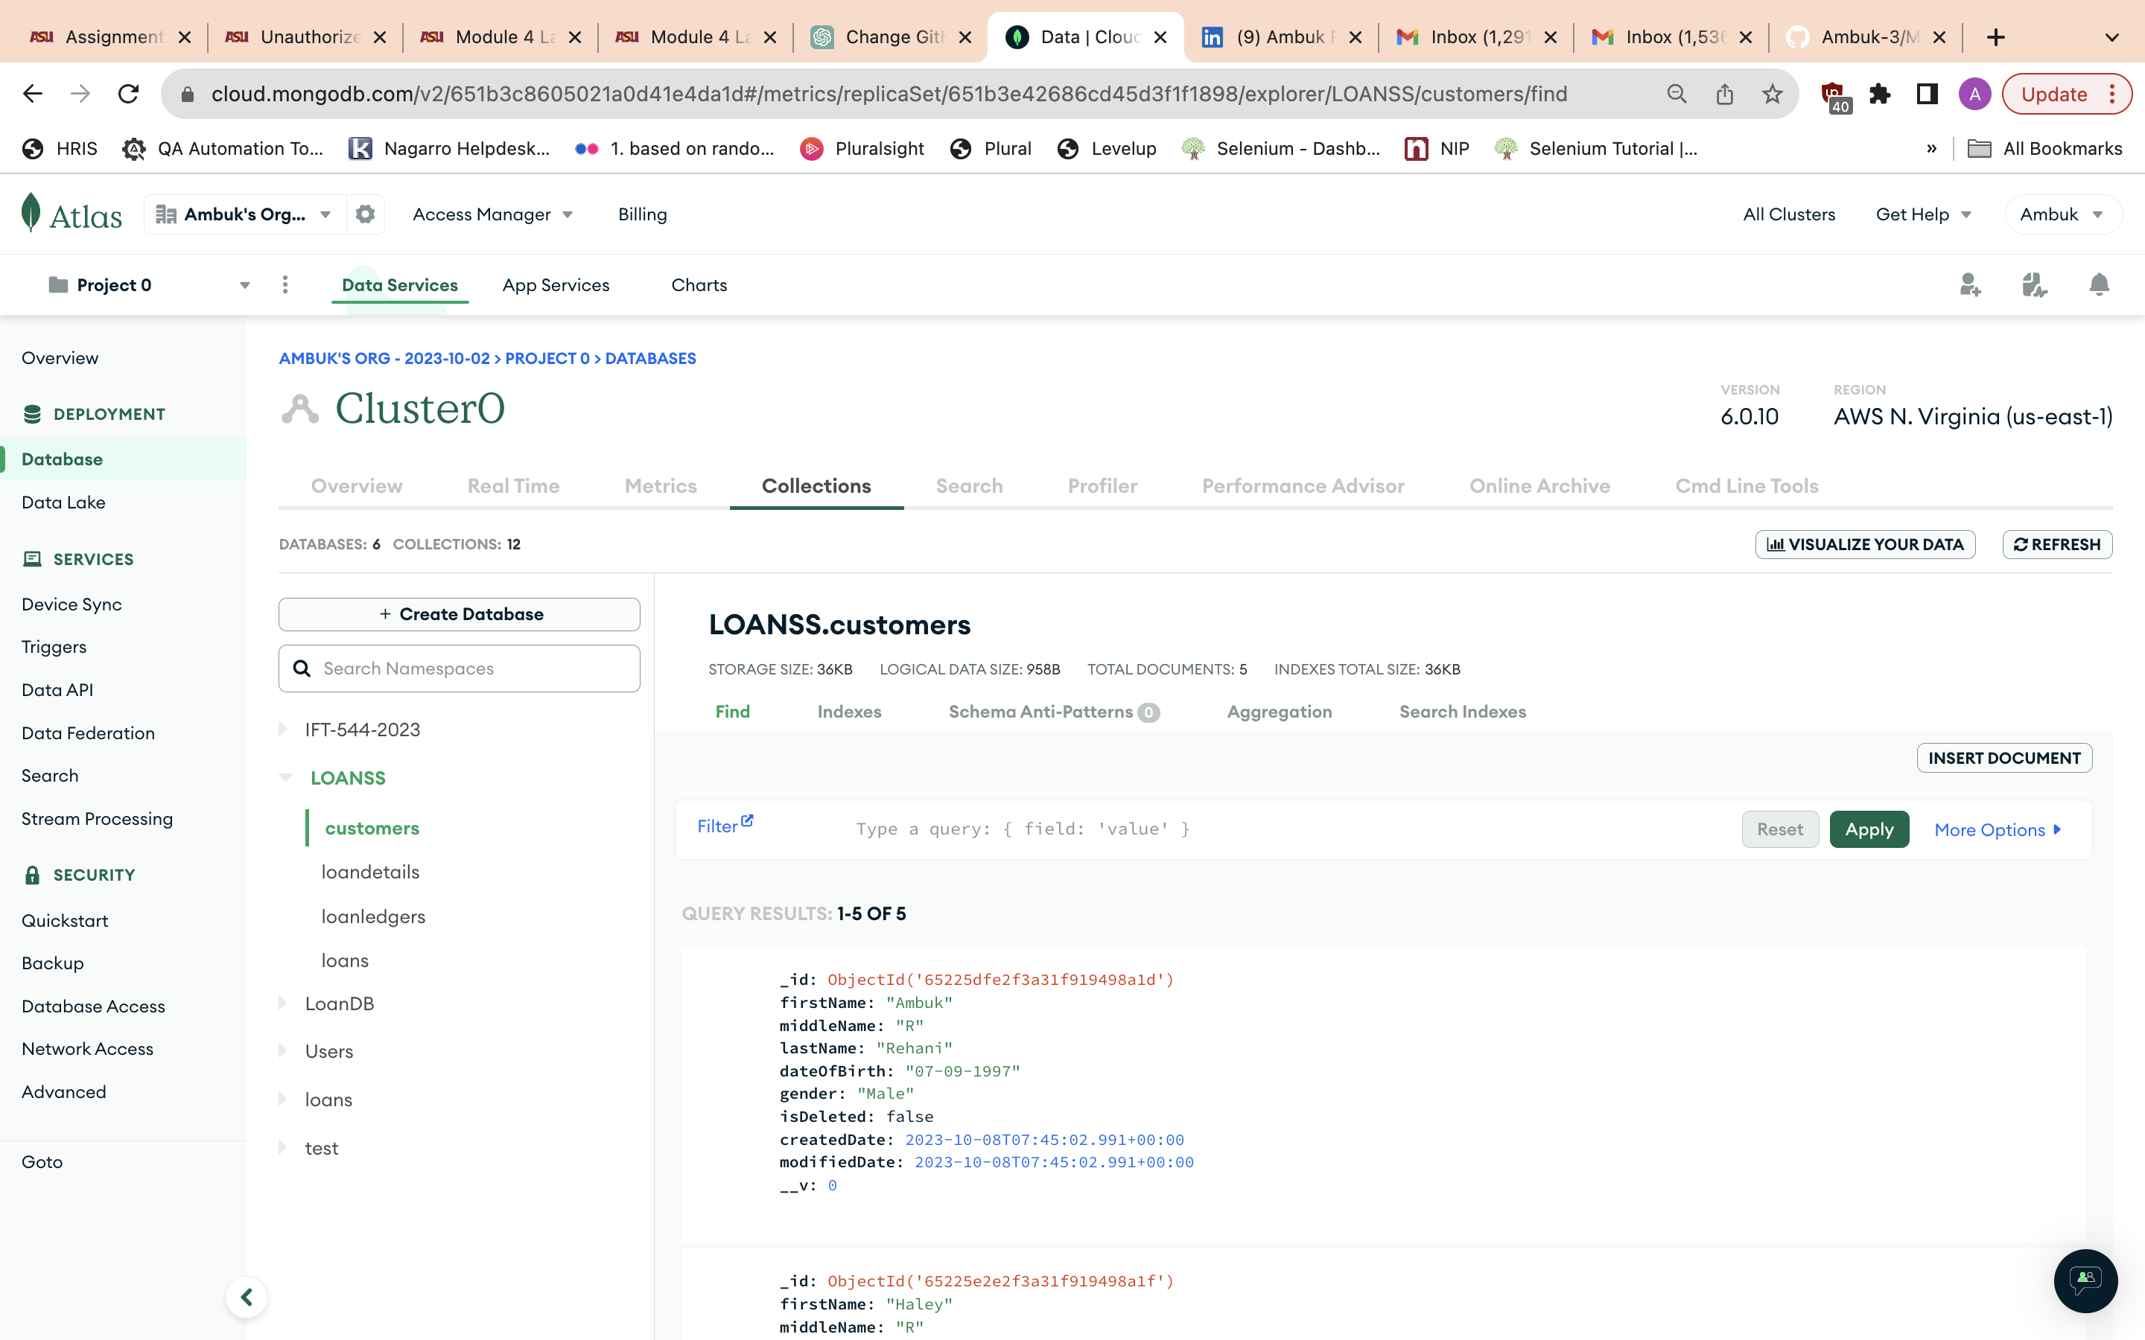

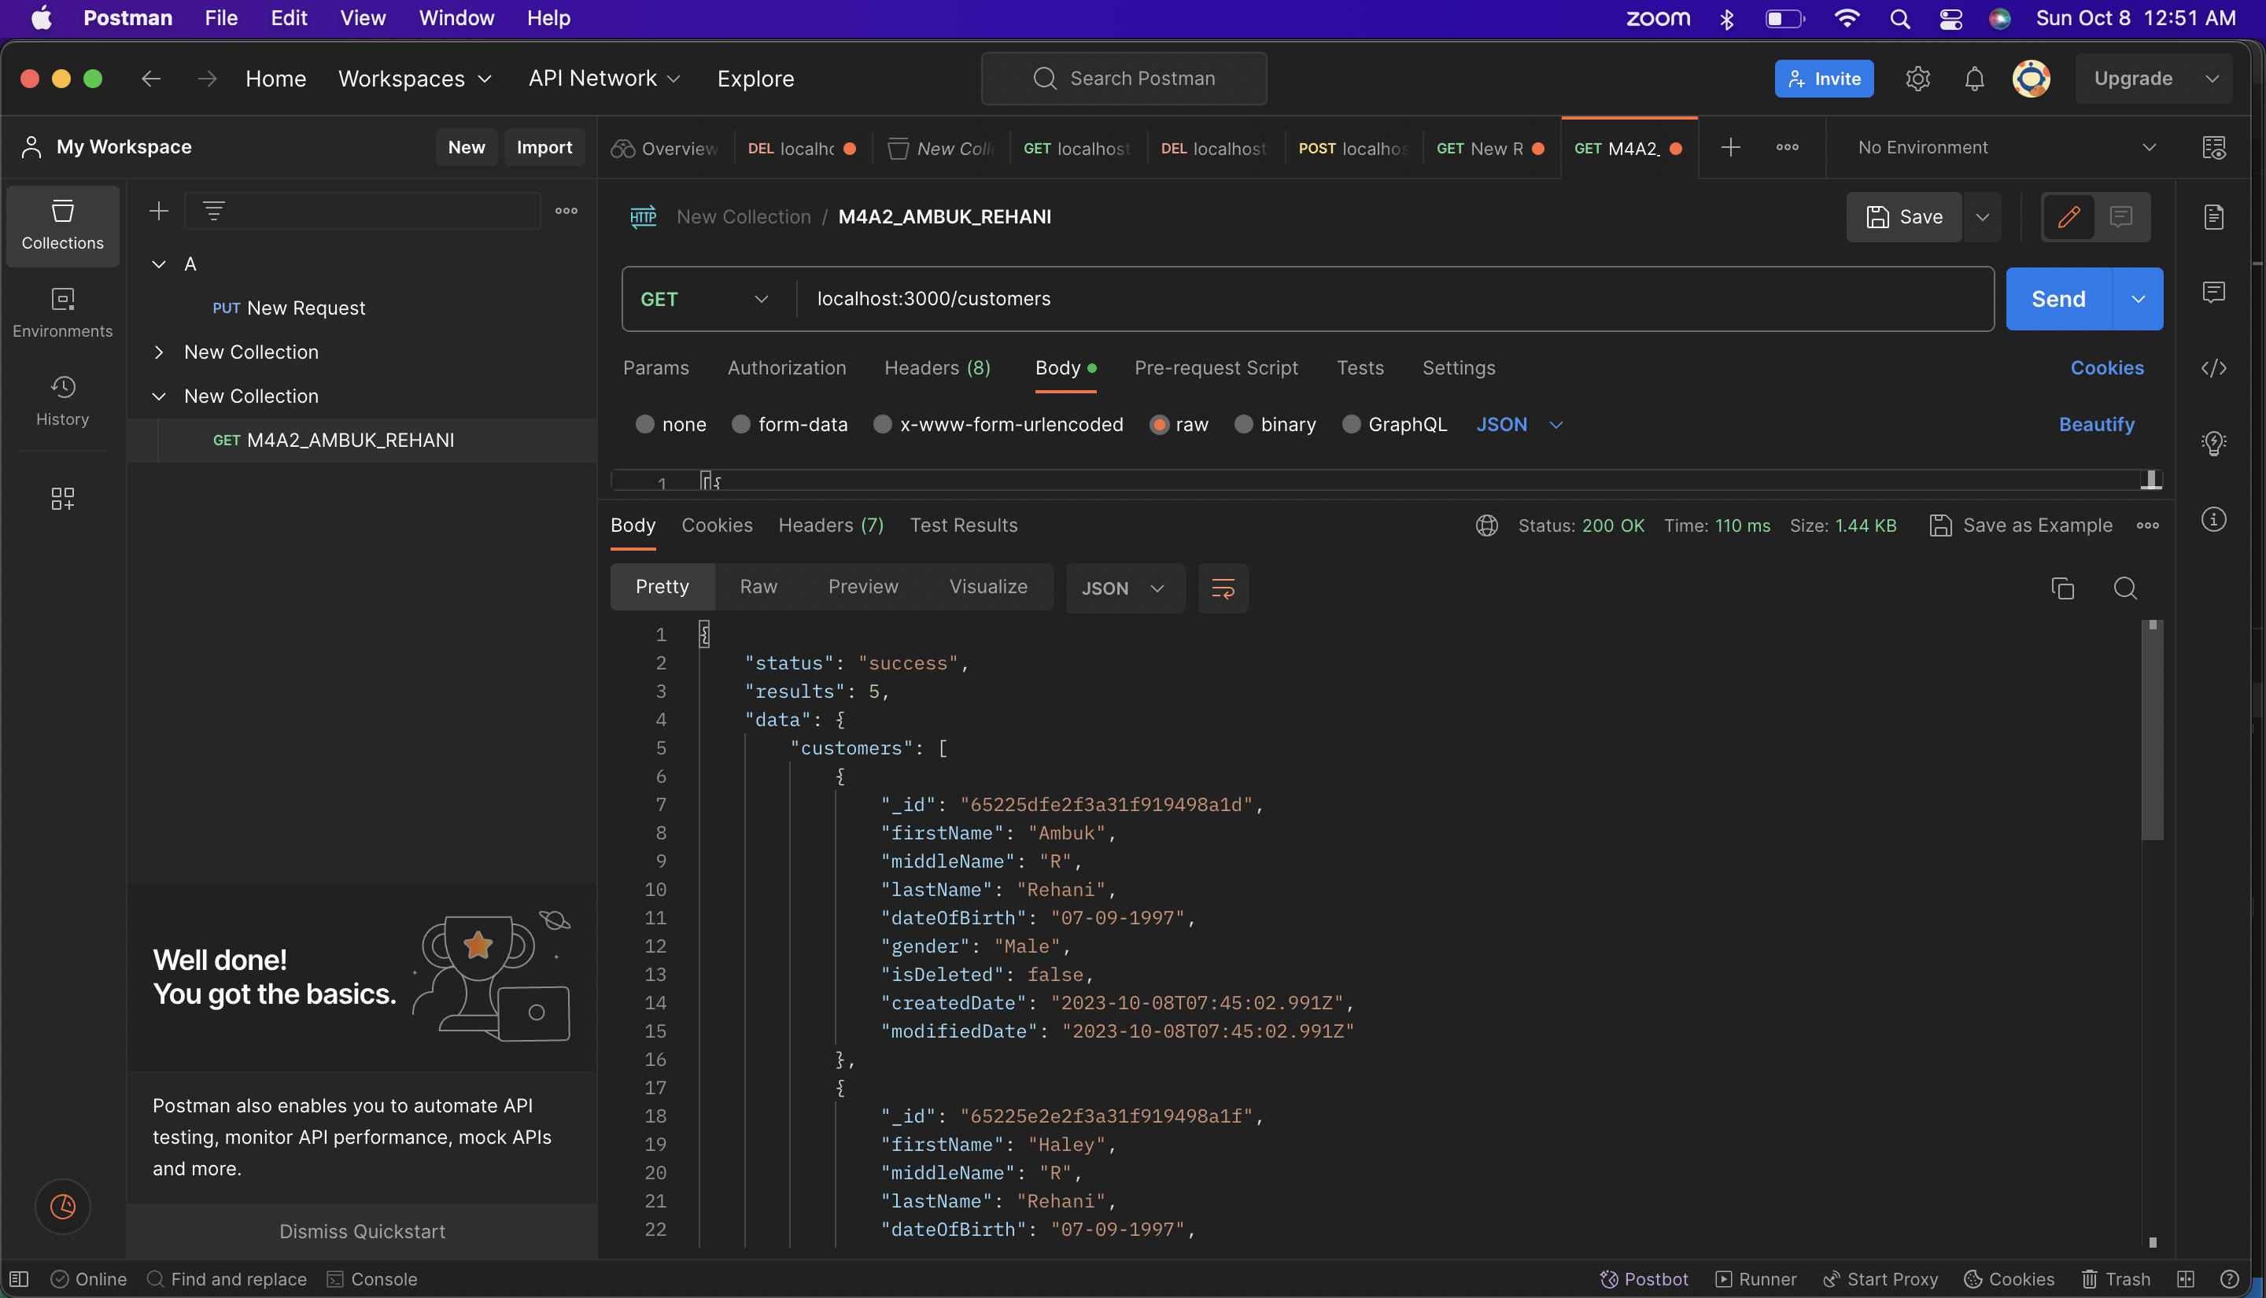

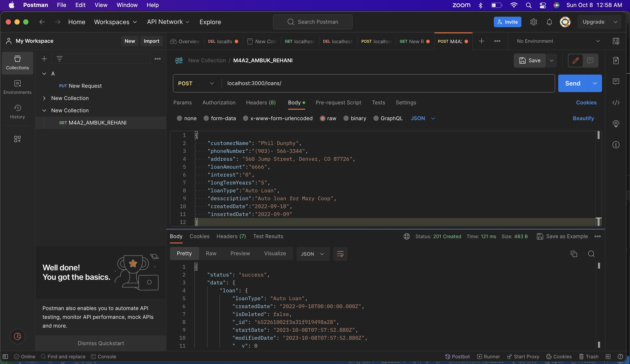

Multiple Loans:

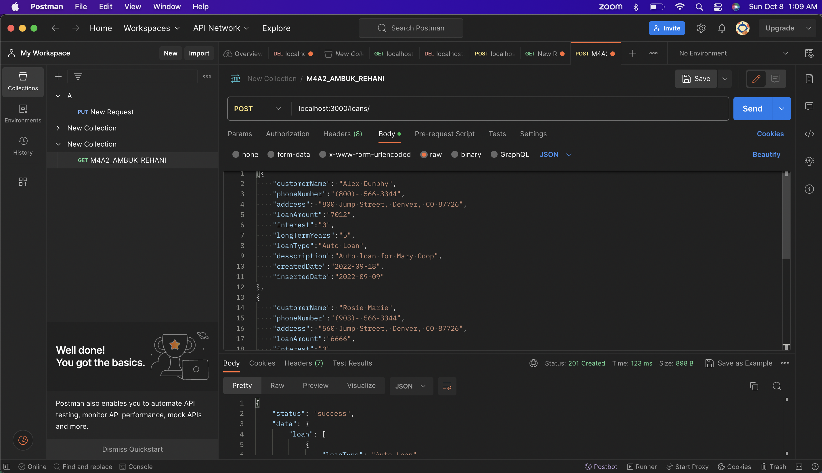

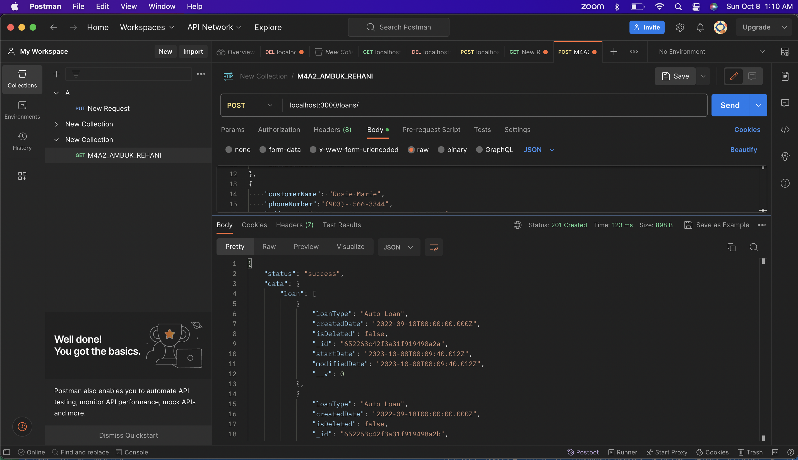

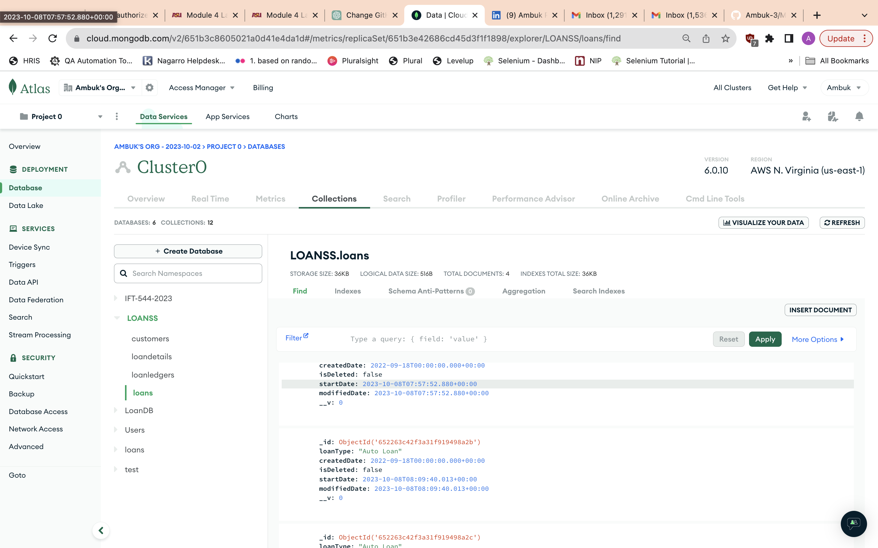

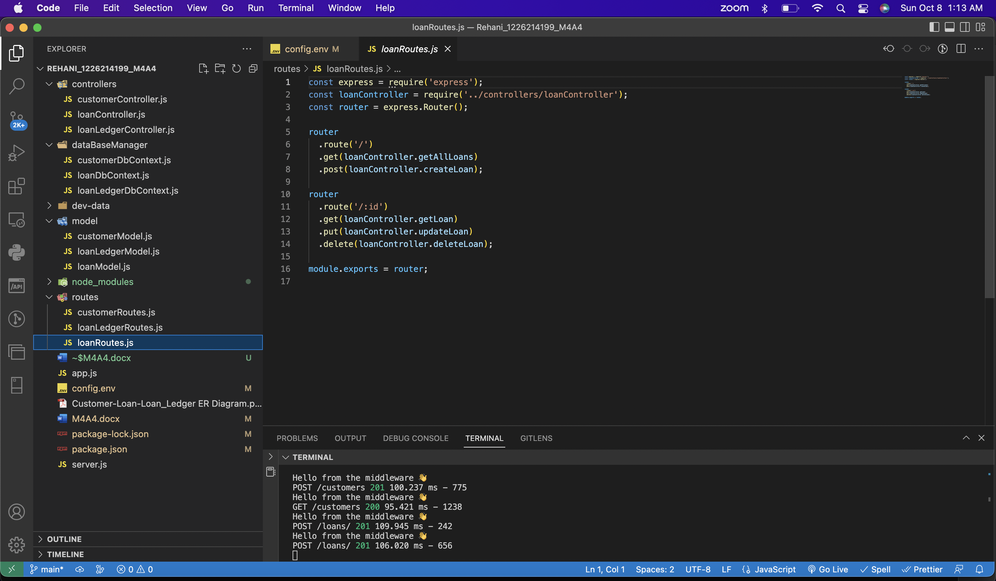









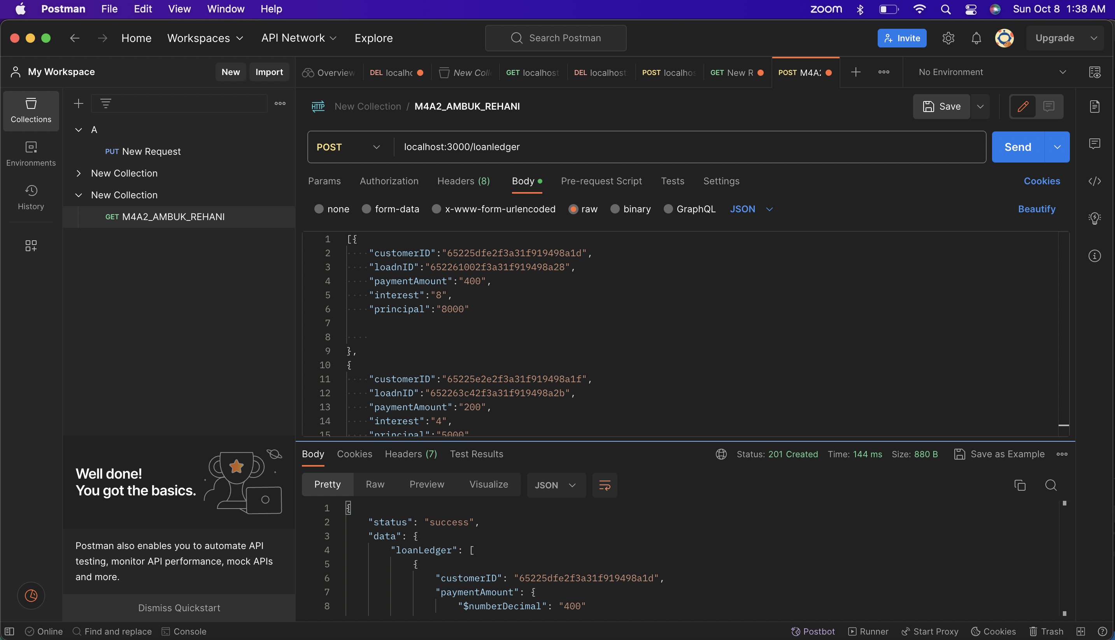

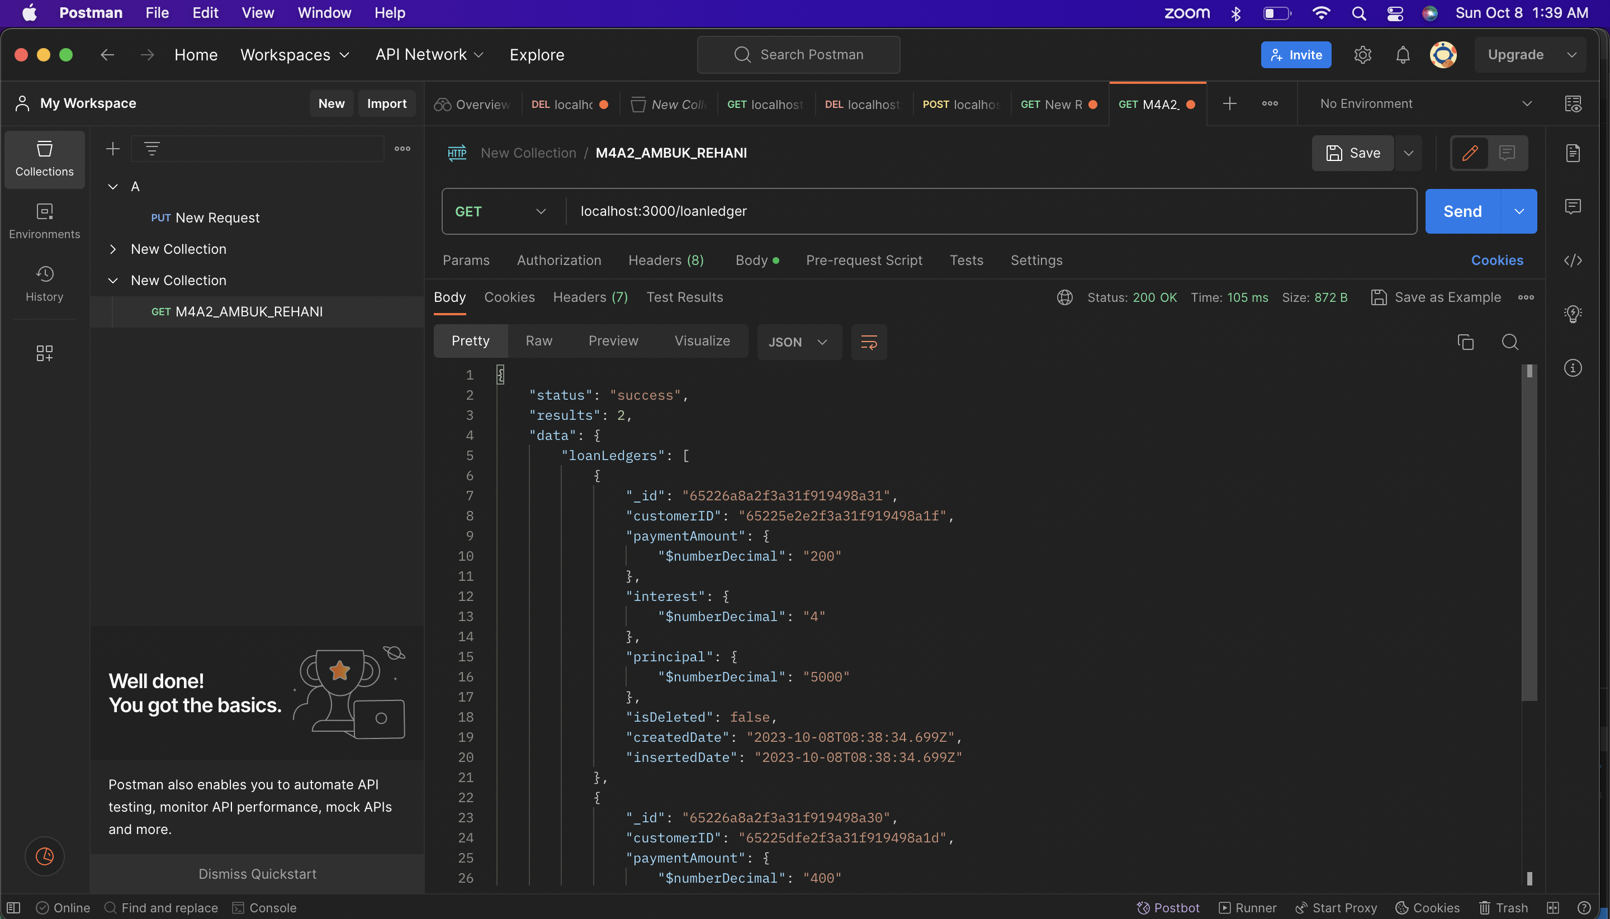

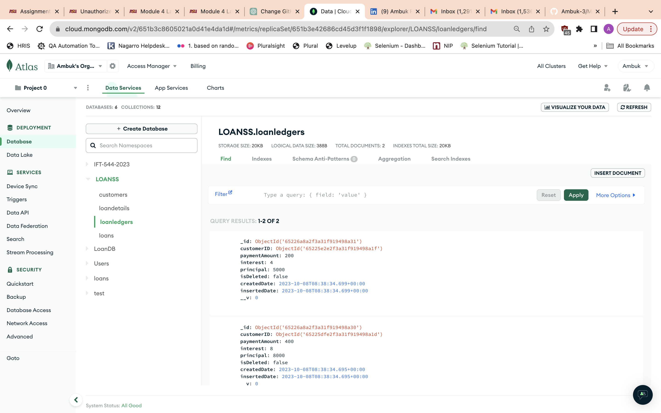

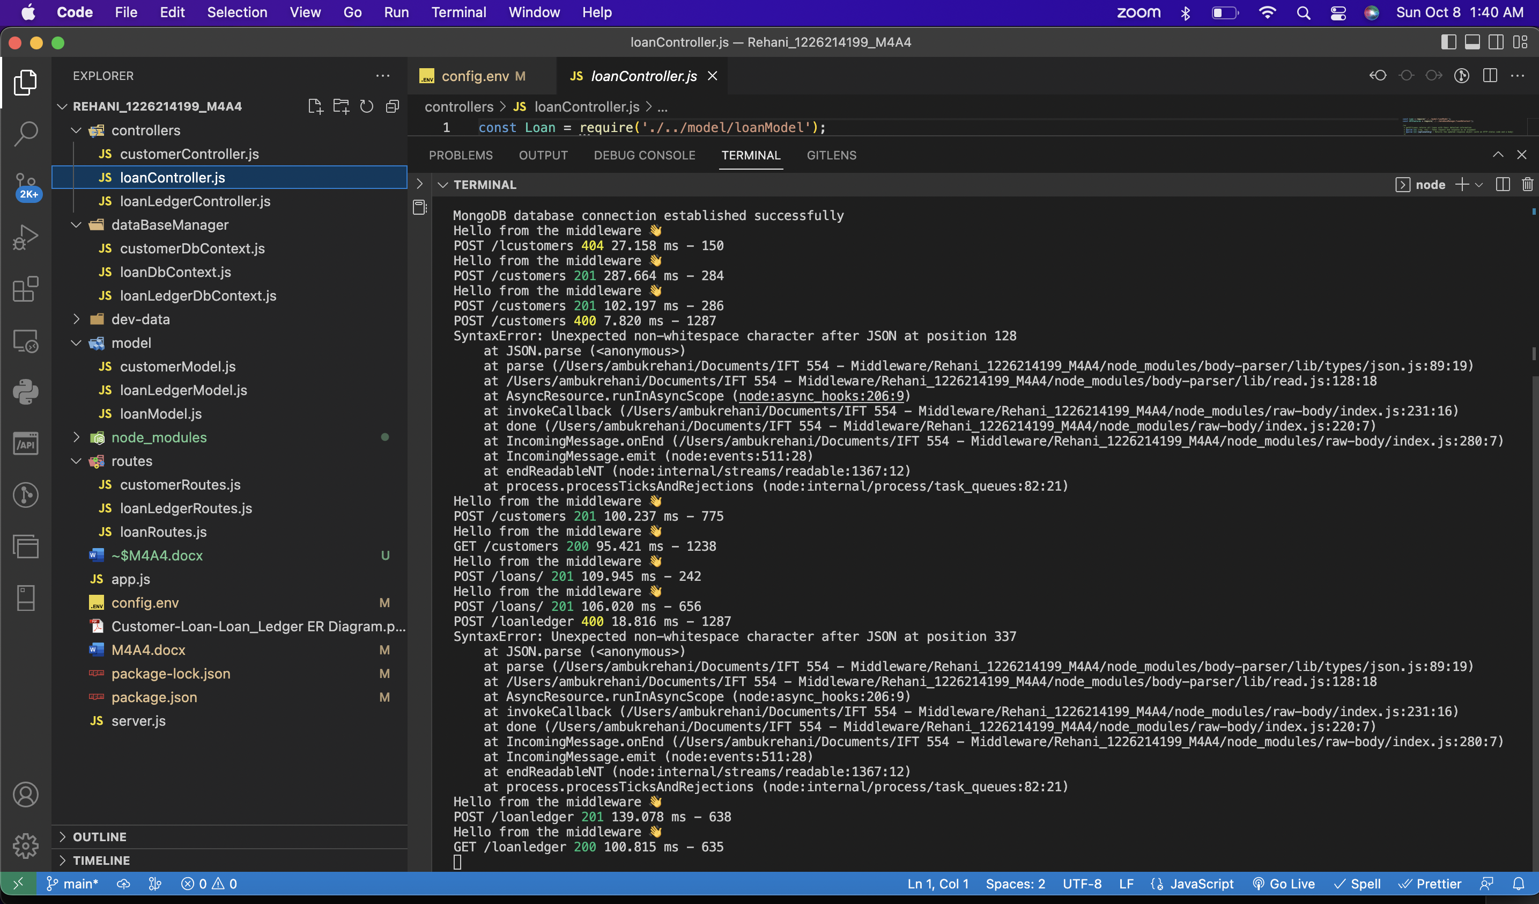

Code:

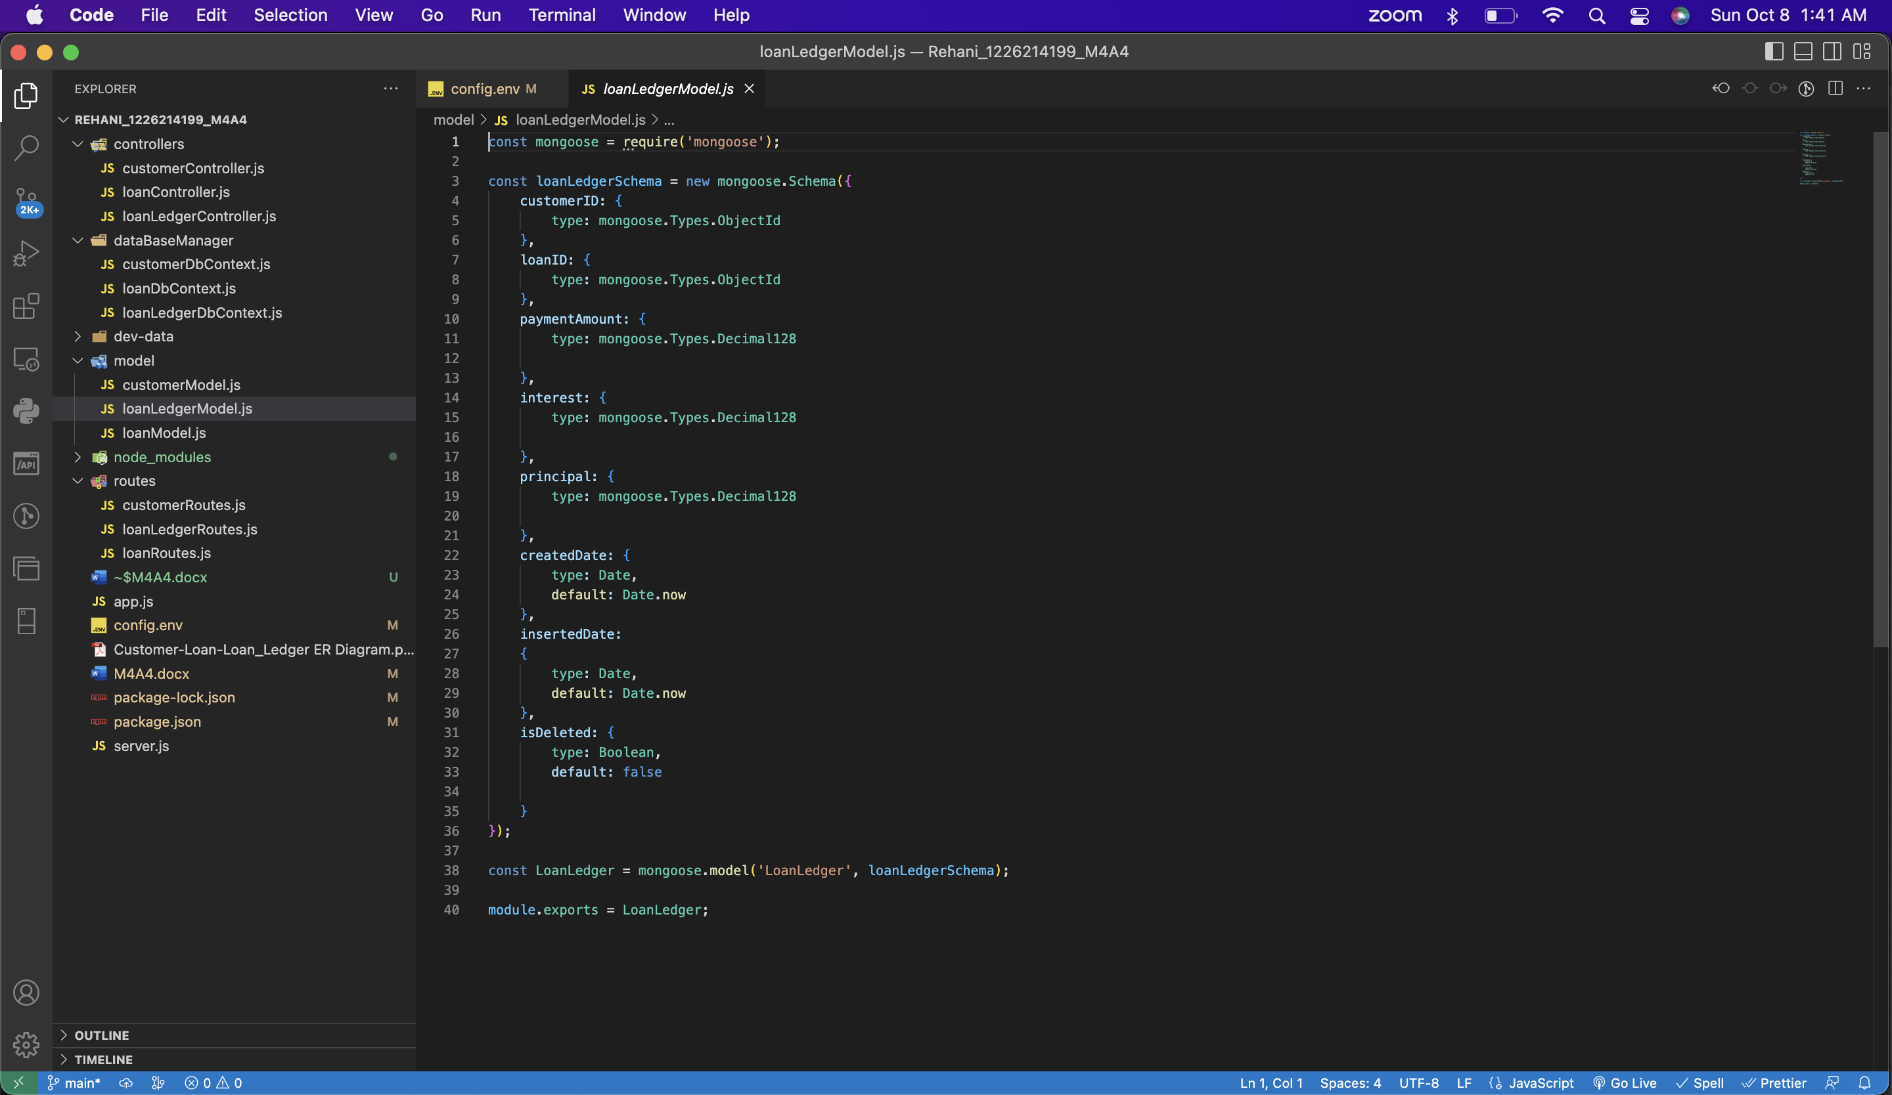

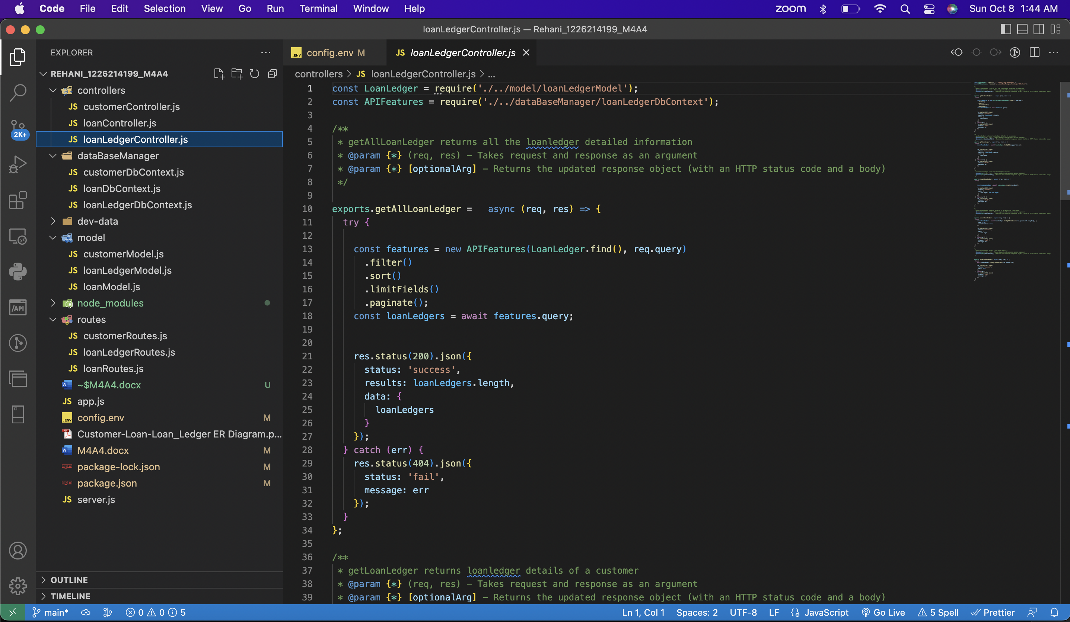

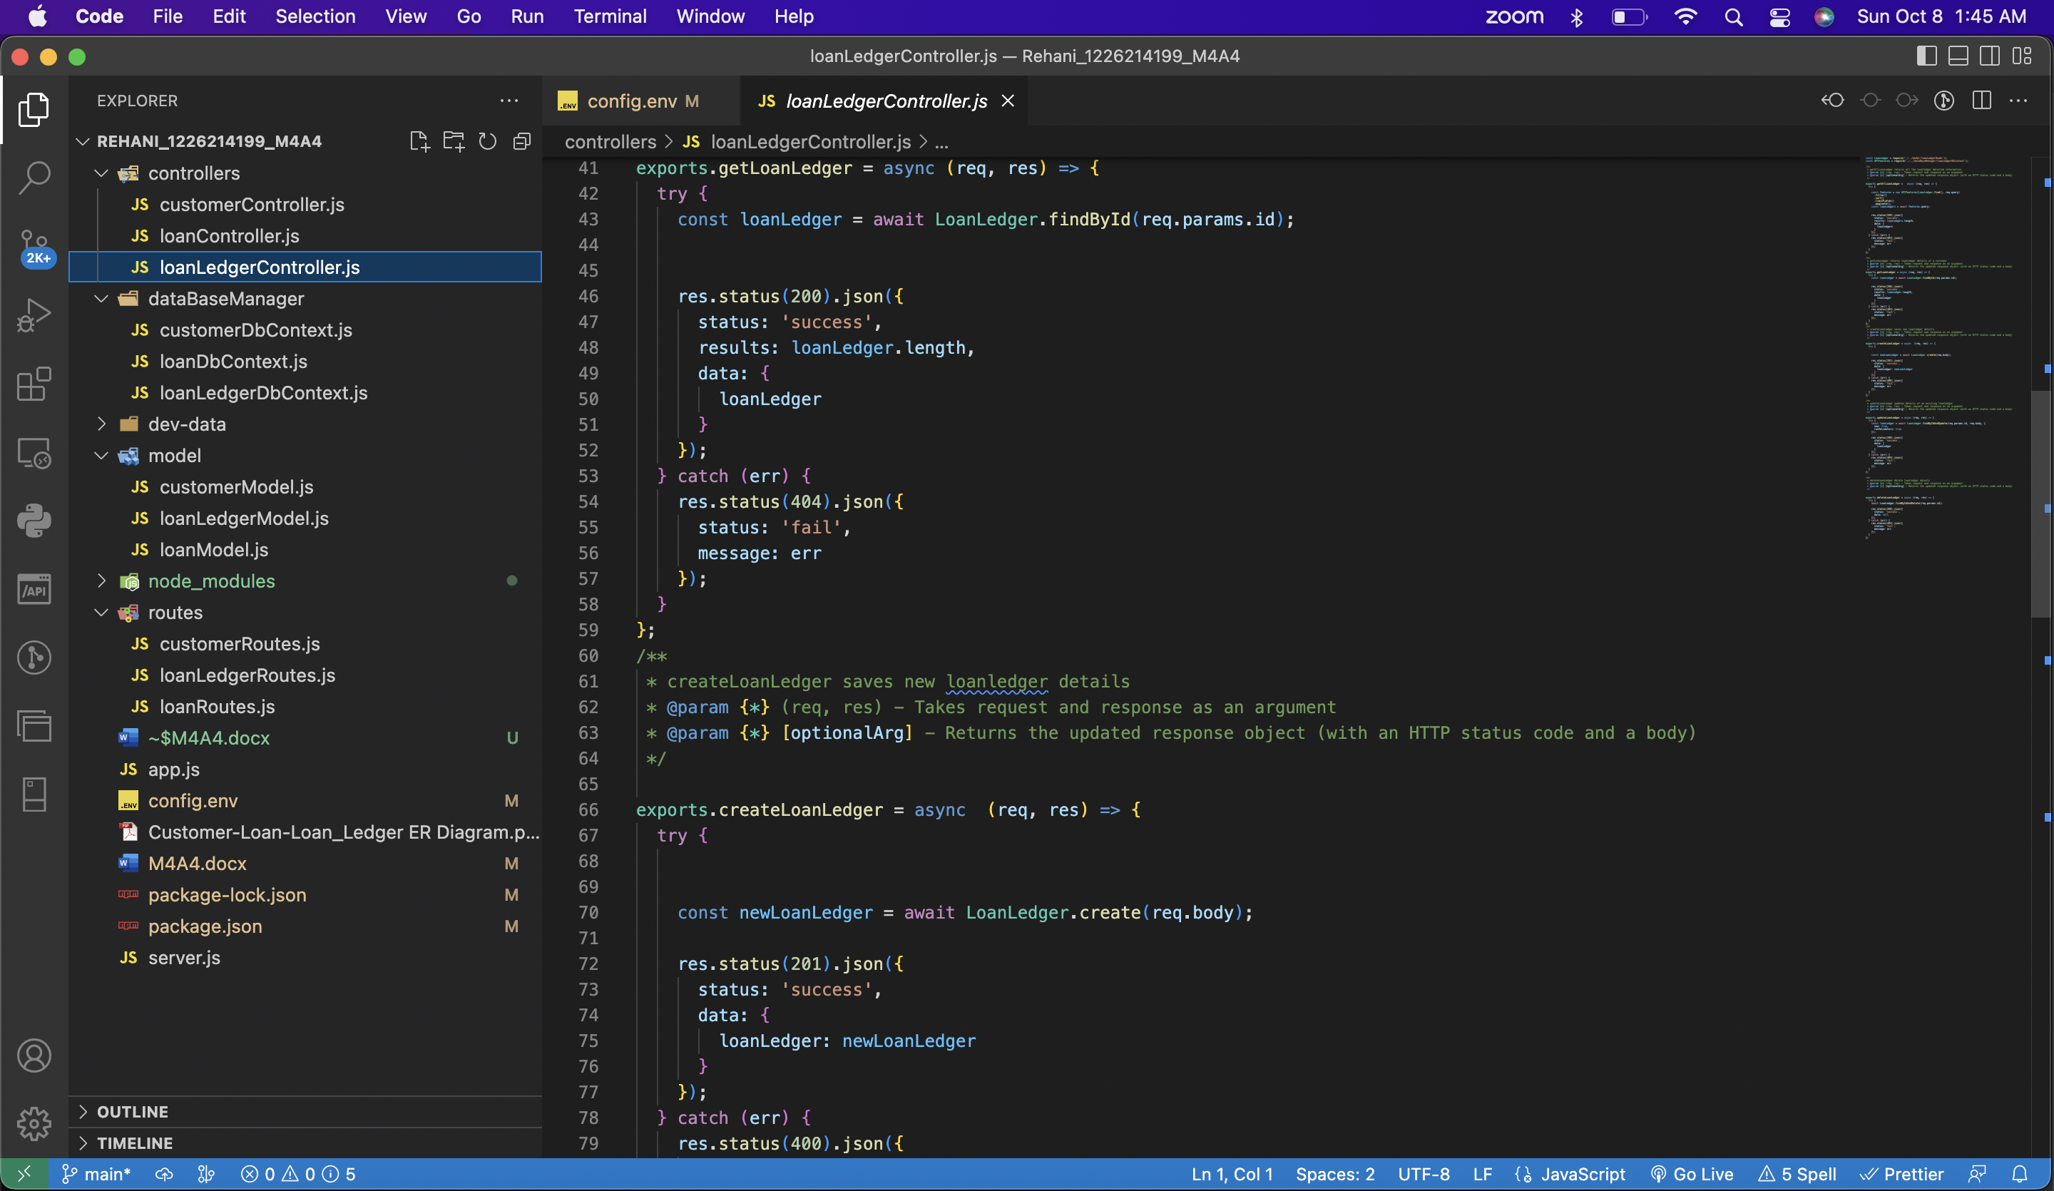

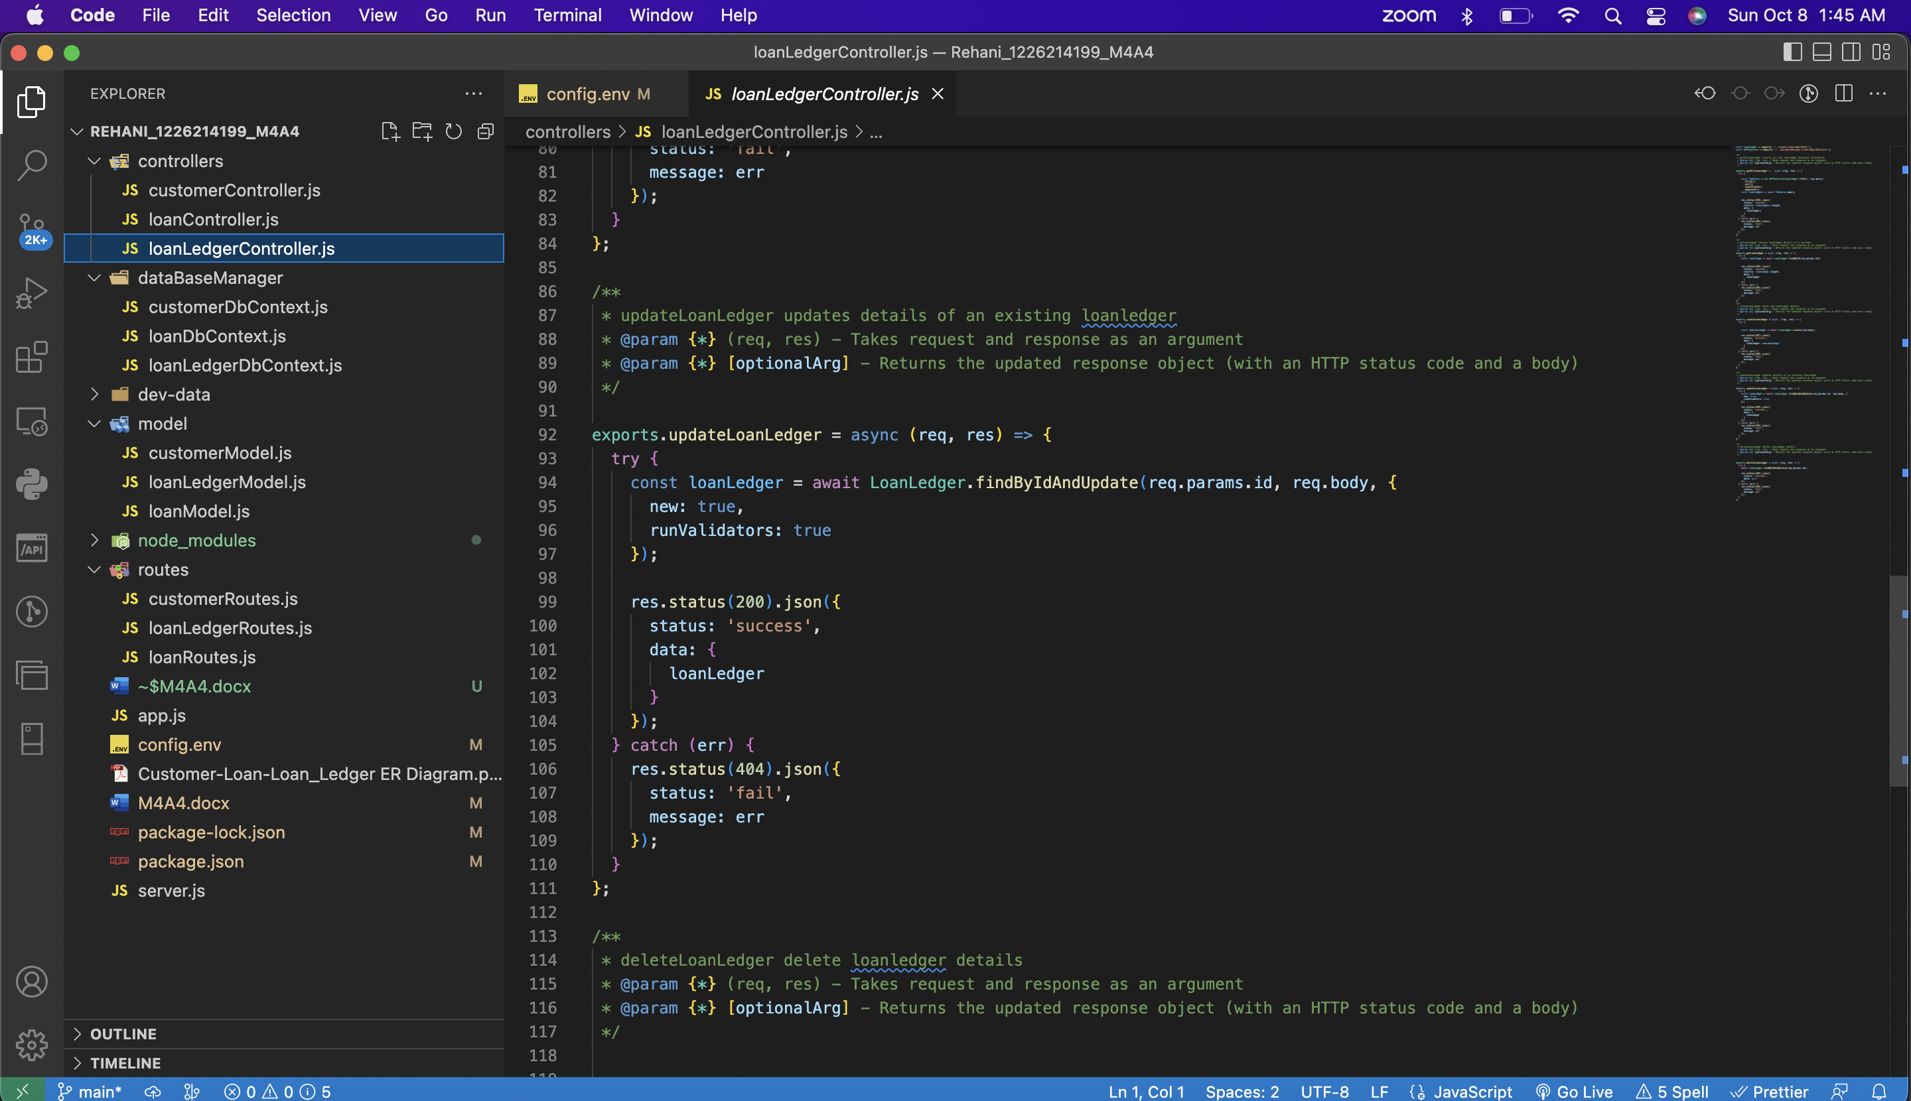

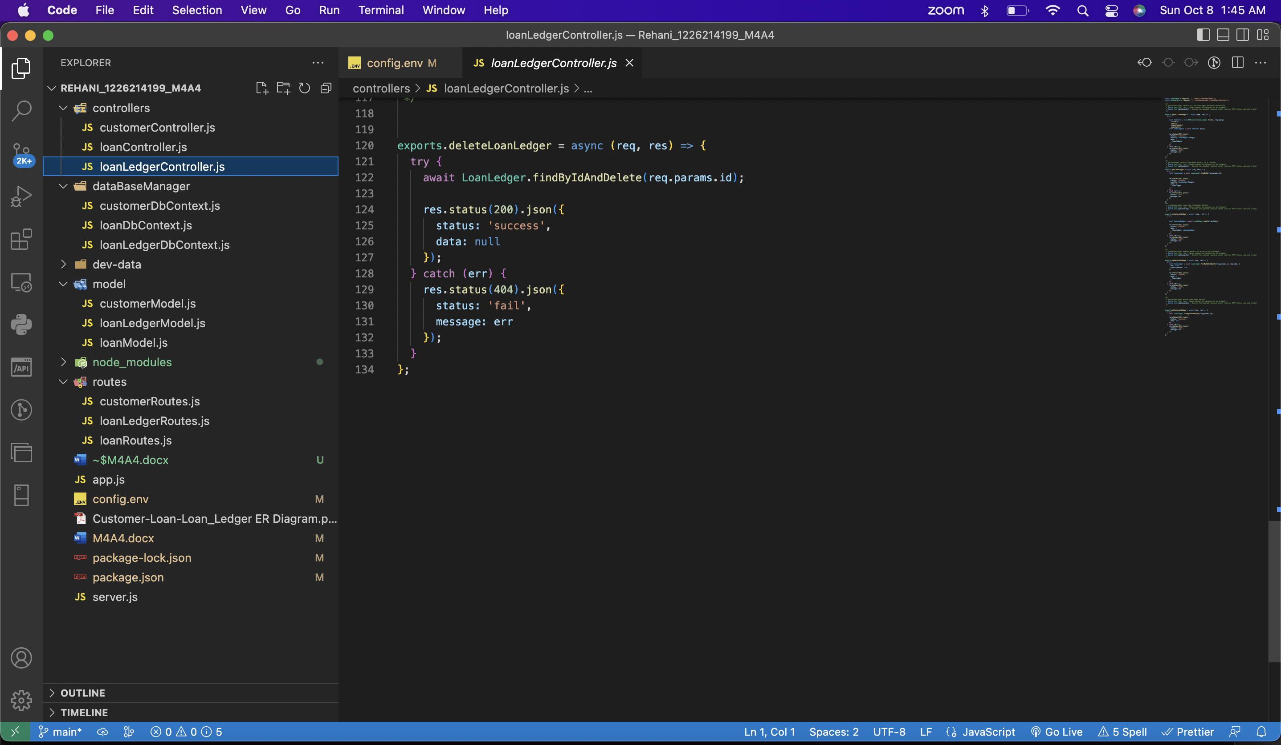

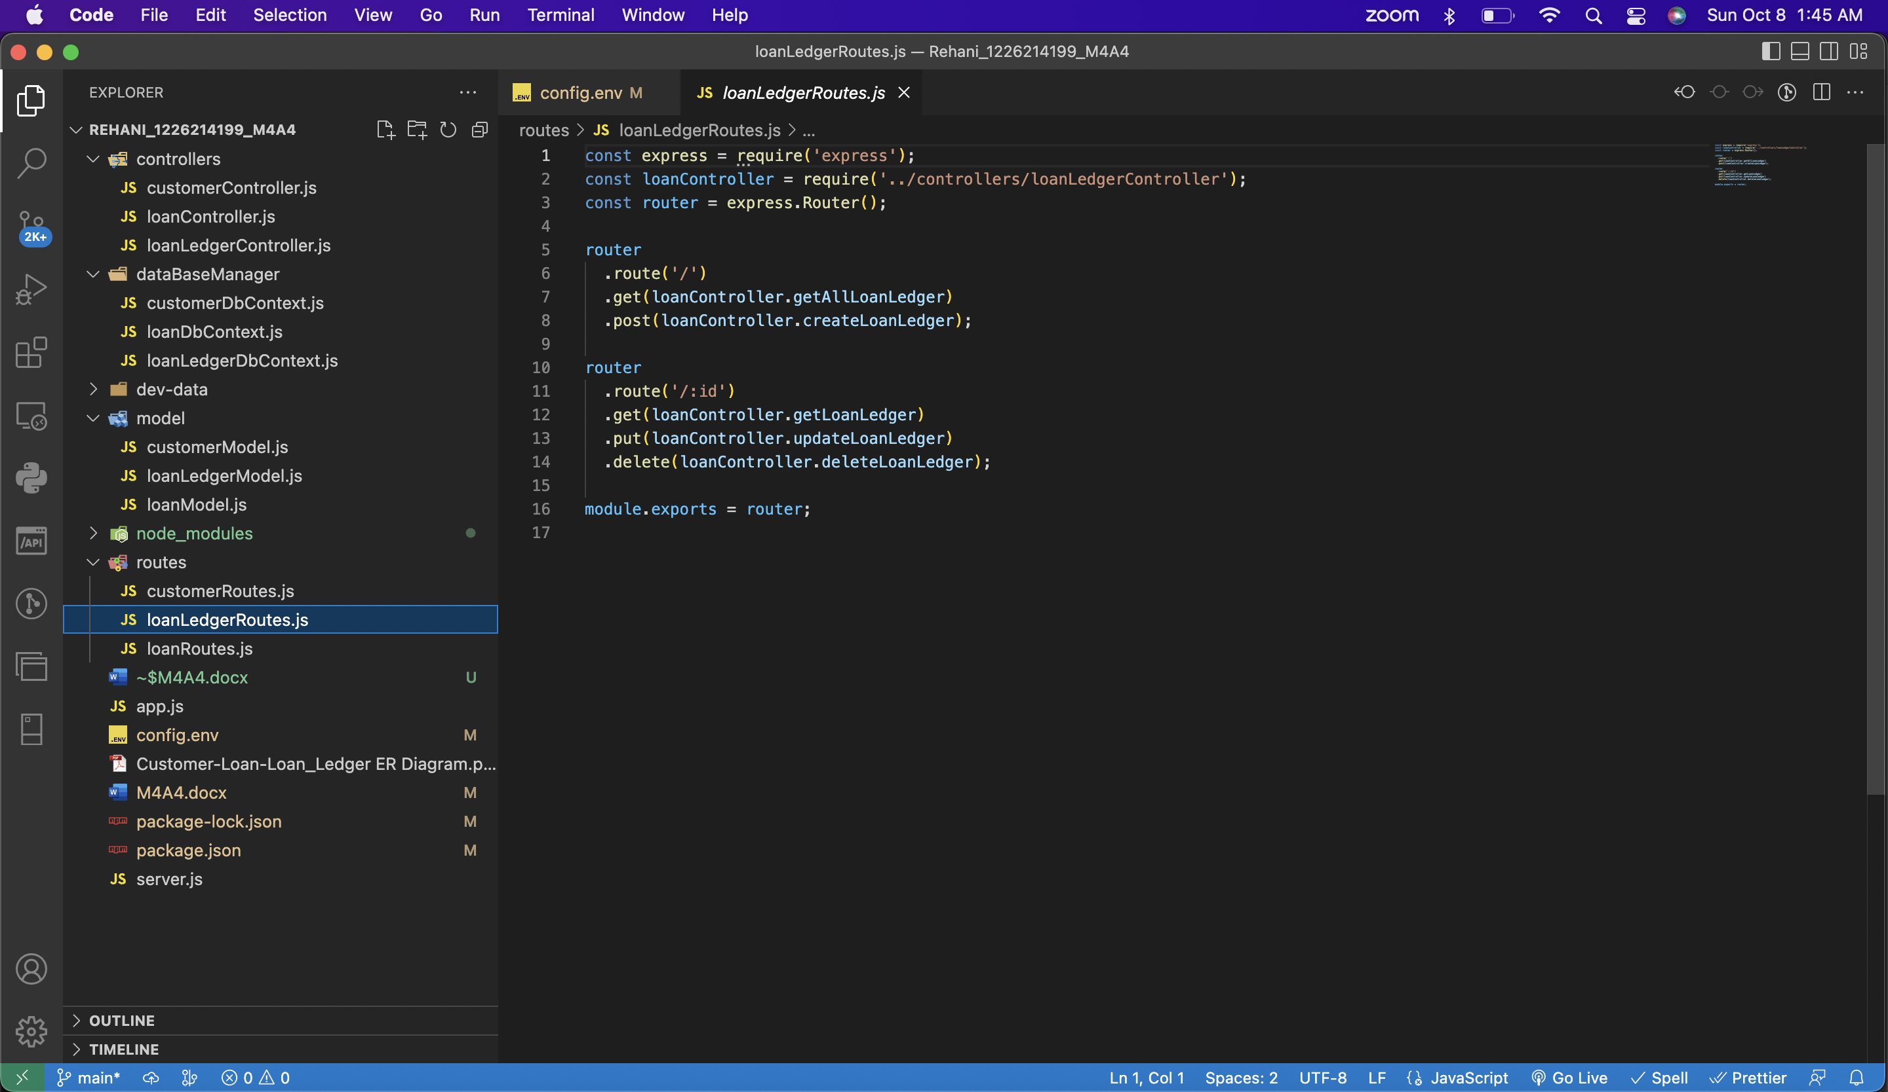

**Part 3: Requirement Storage Design Implementation: (DATABASE)**

**Create a Node.js Project to Access, and implement using Rest methods. Document and comment on all parts of the code and implementations as you see fit.**

* SELECT ( Get),
* INSERT( Post)
* UPDATE (Update)
* and DELETE (Delete)

**Part 4:** Use POSTMAN as a client application to test your App server and the Middleware.

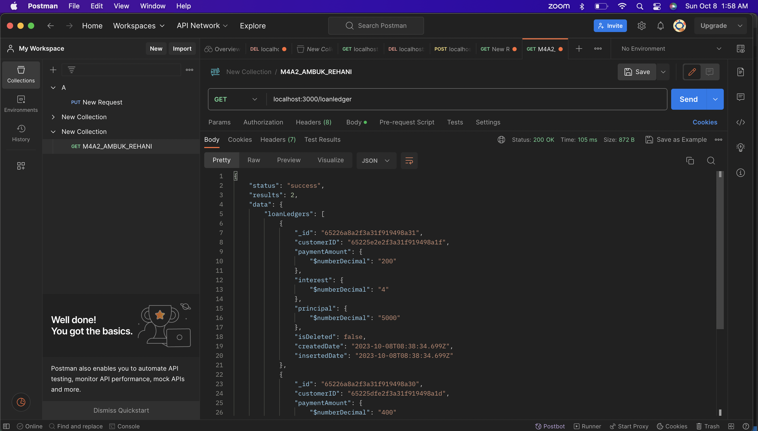

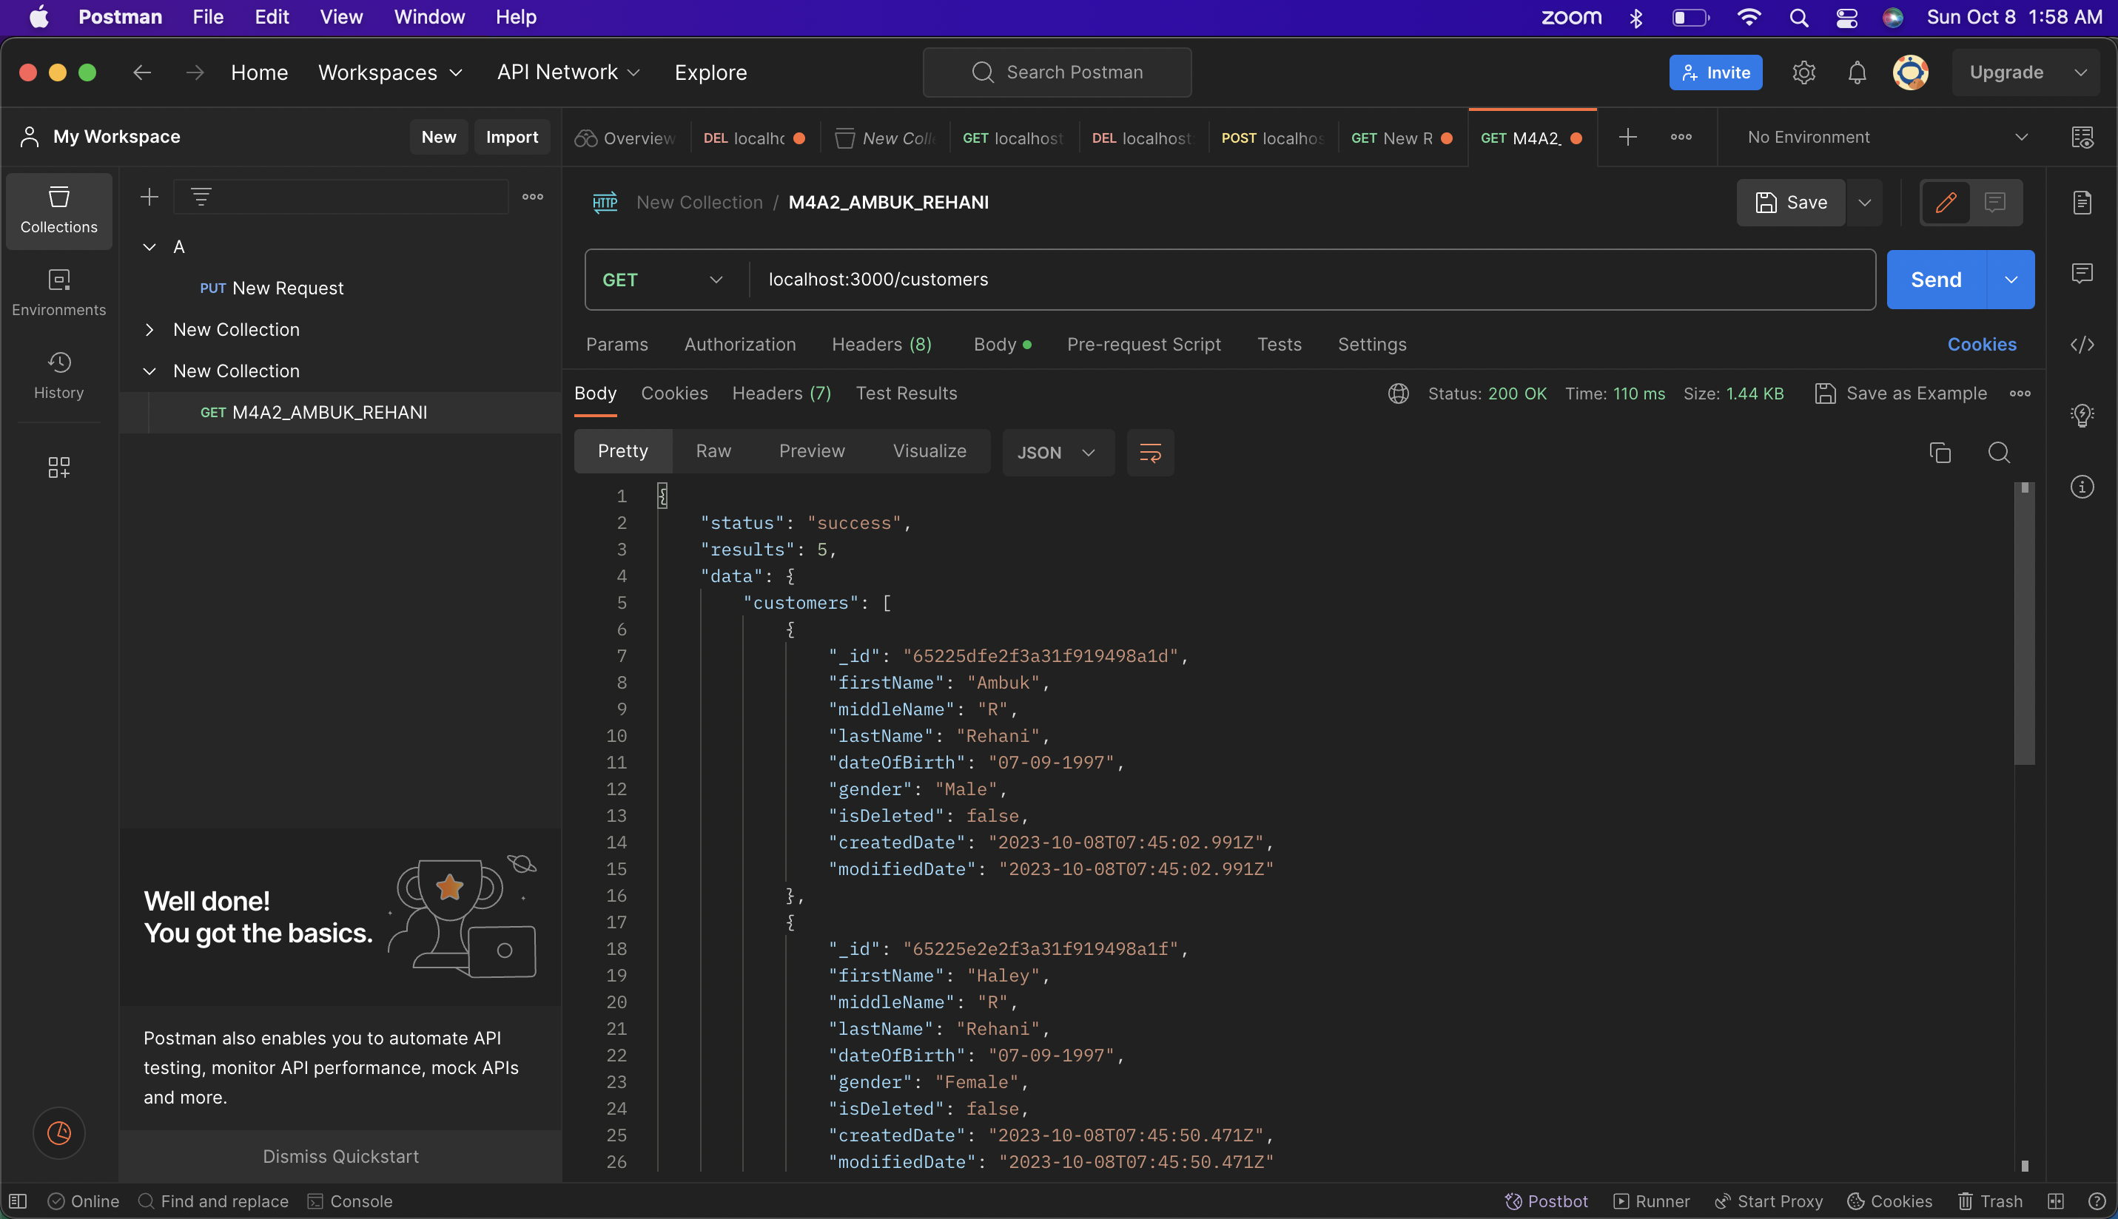

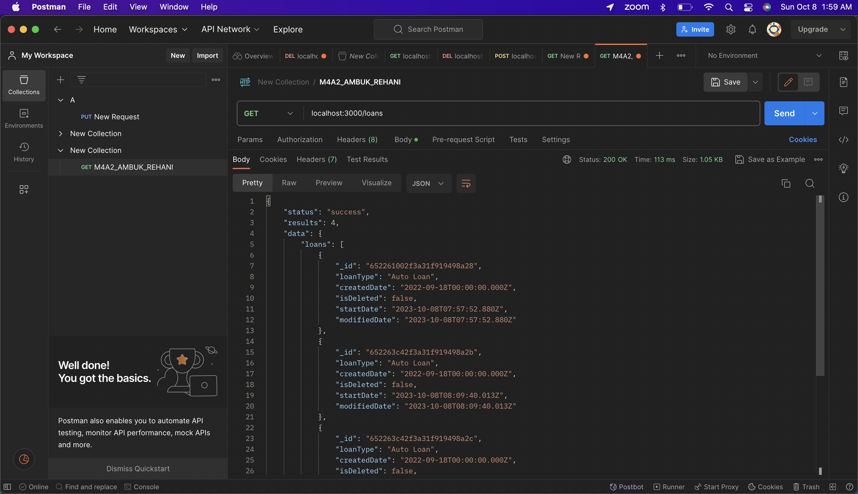

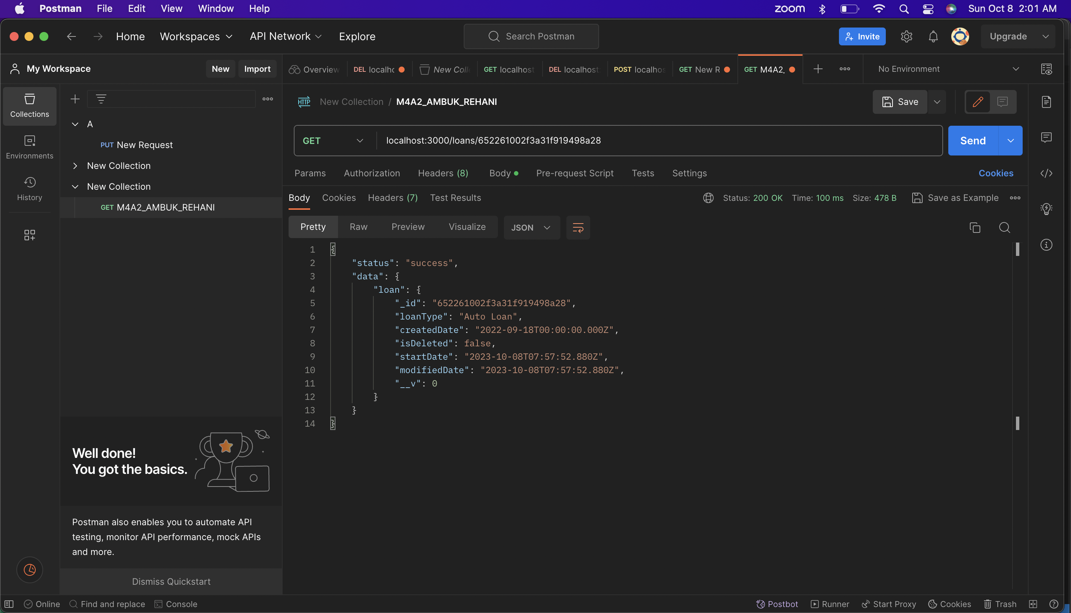

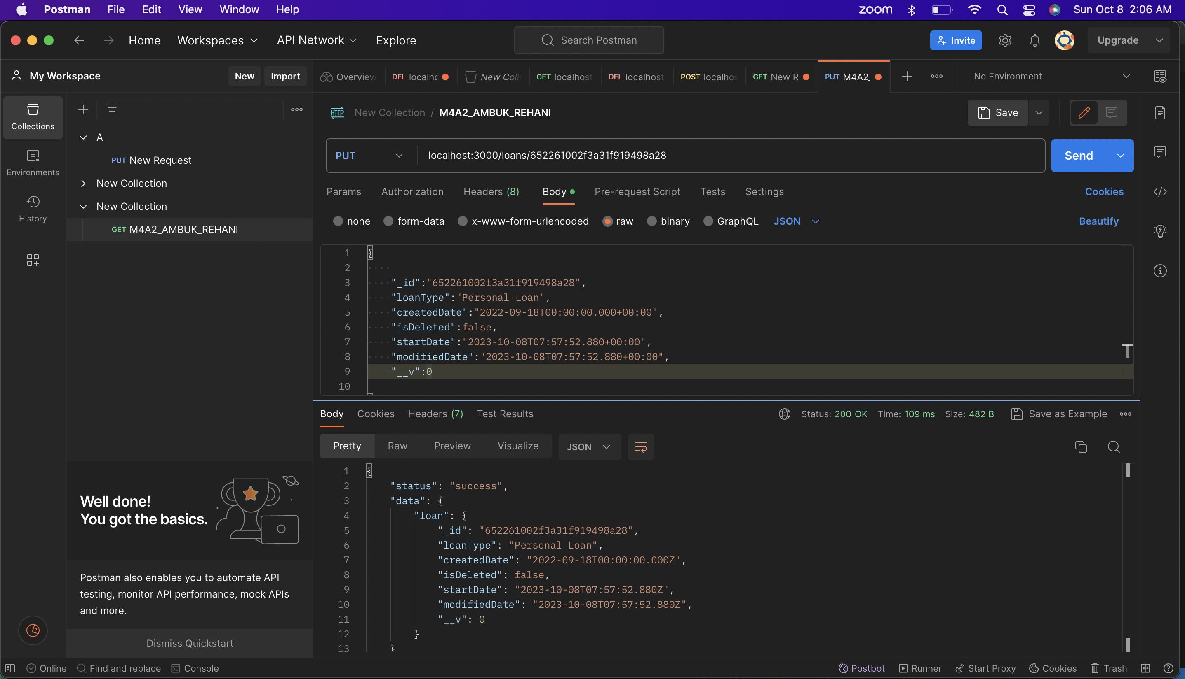

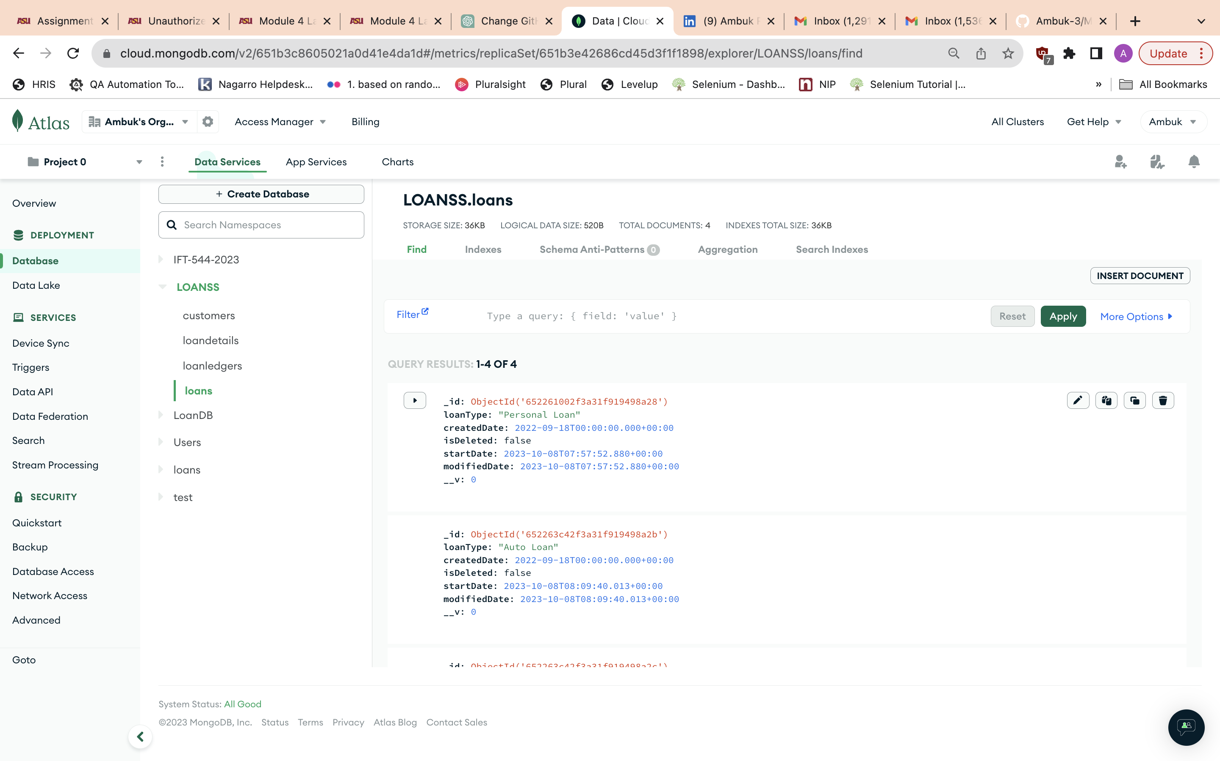

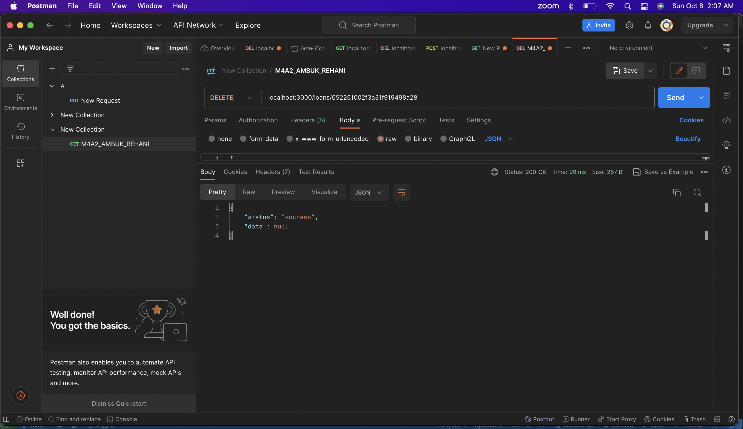

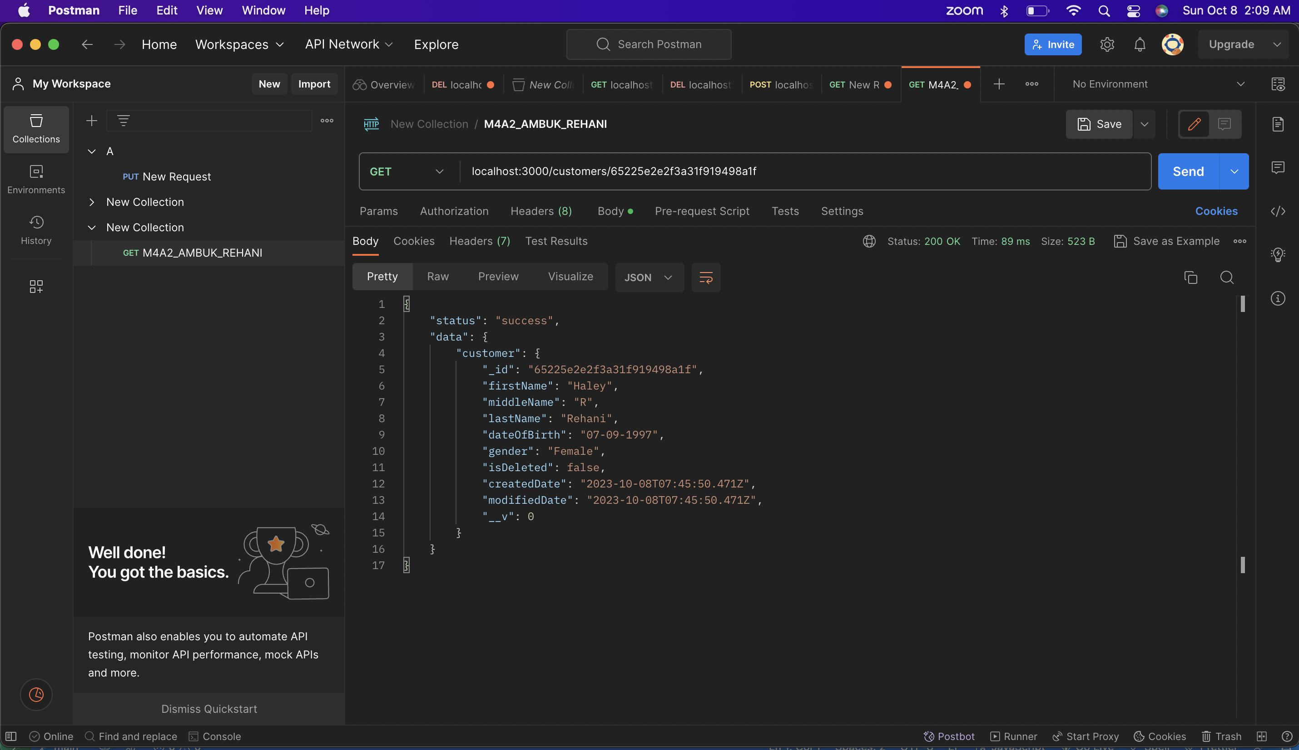

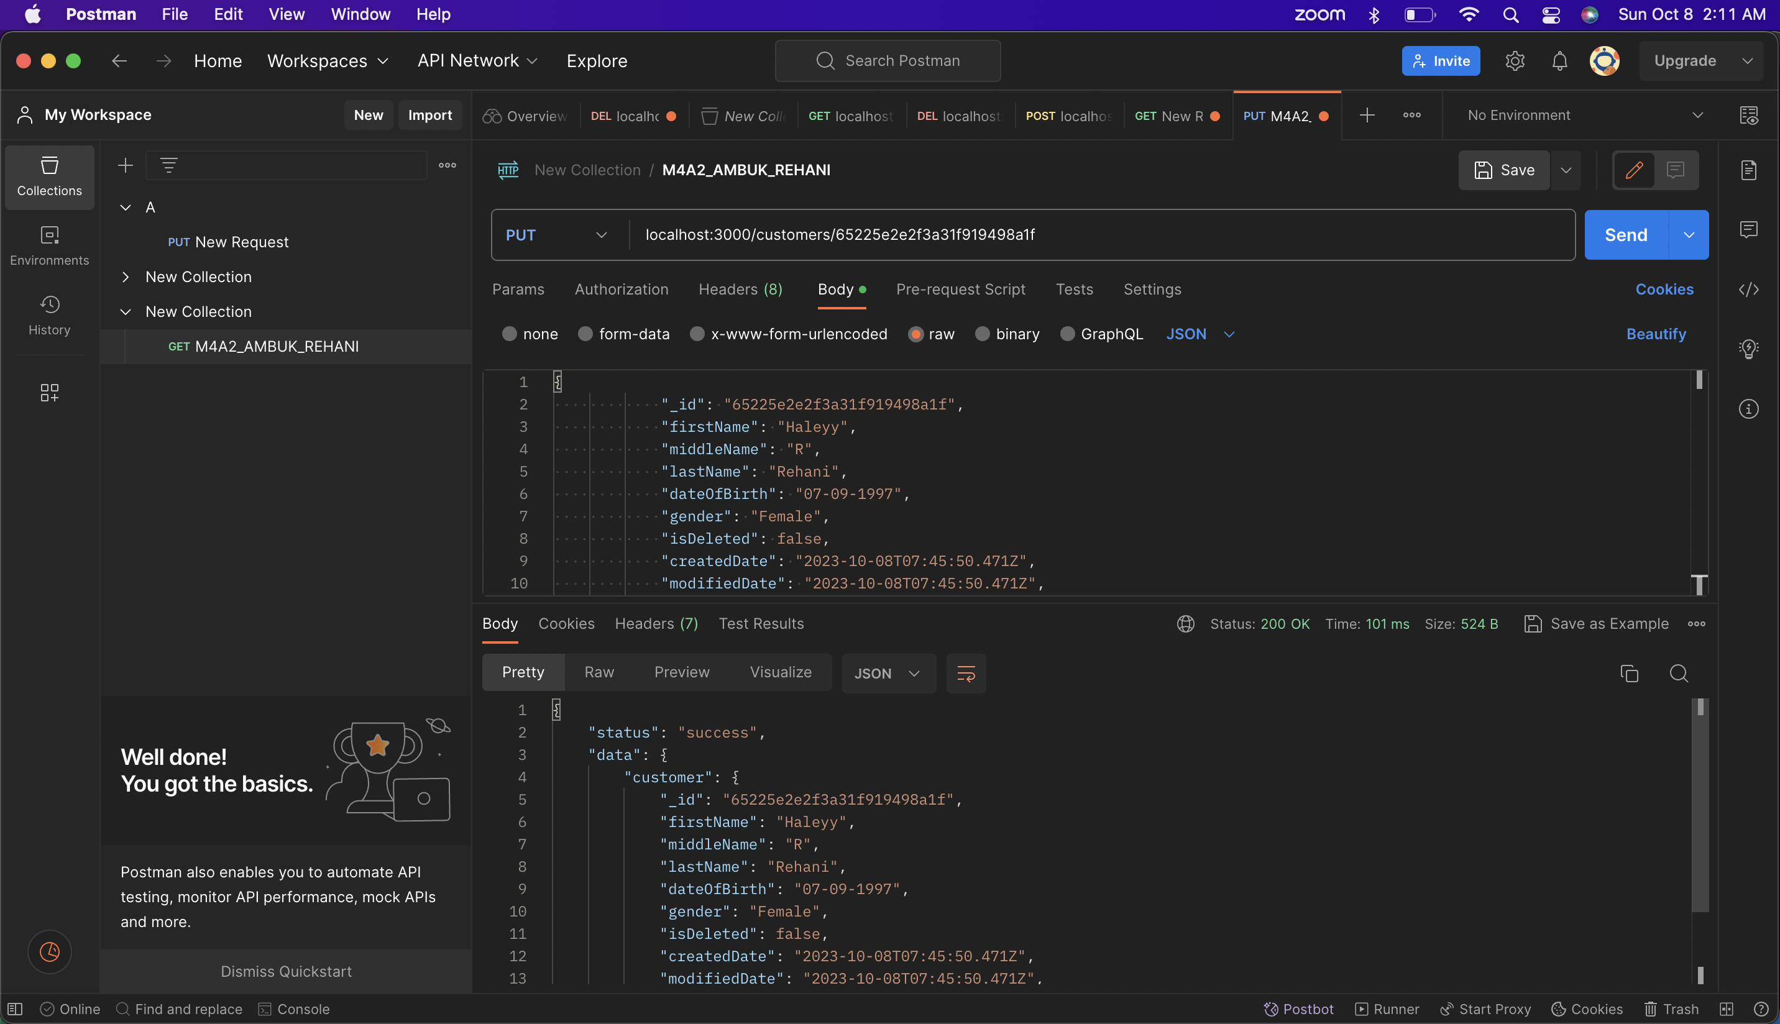

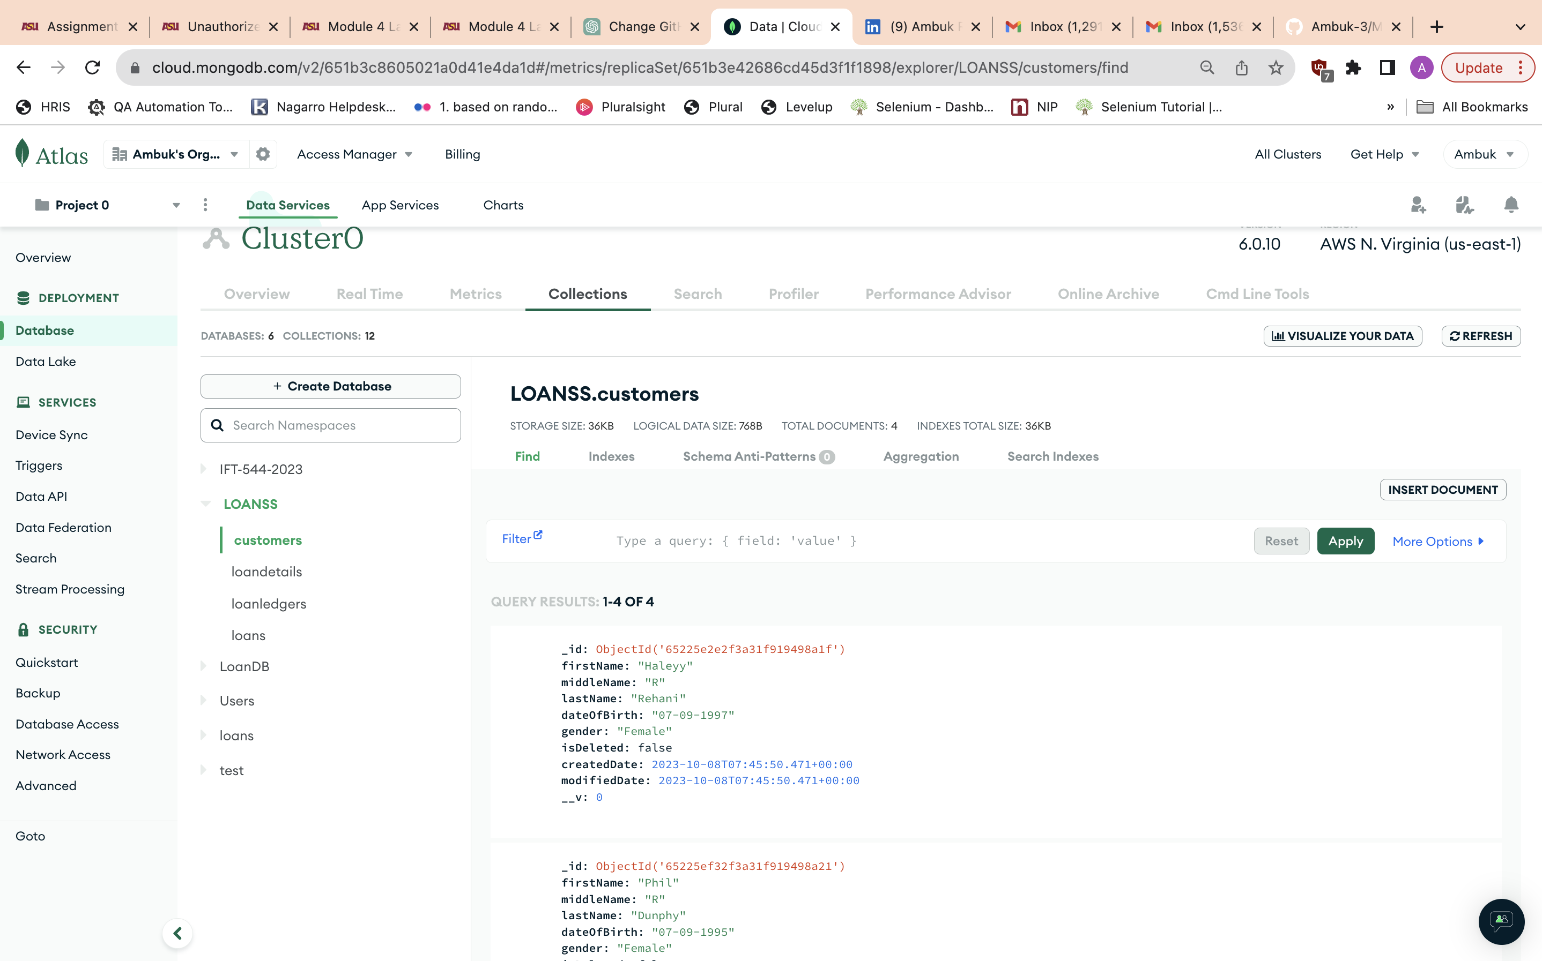

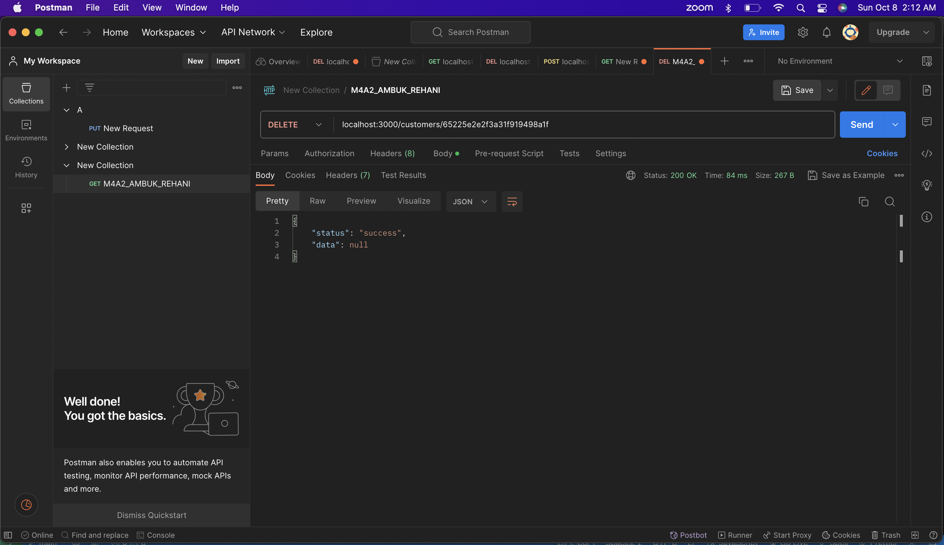

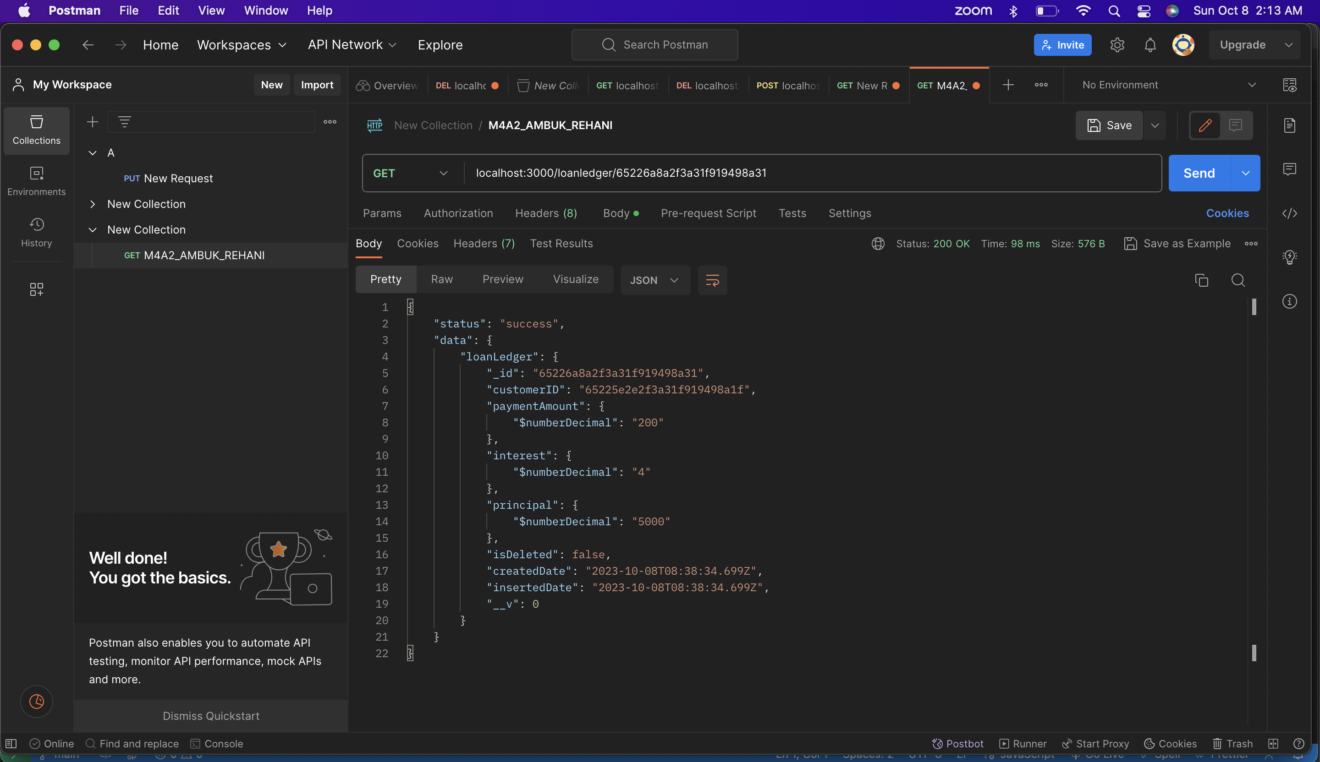

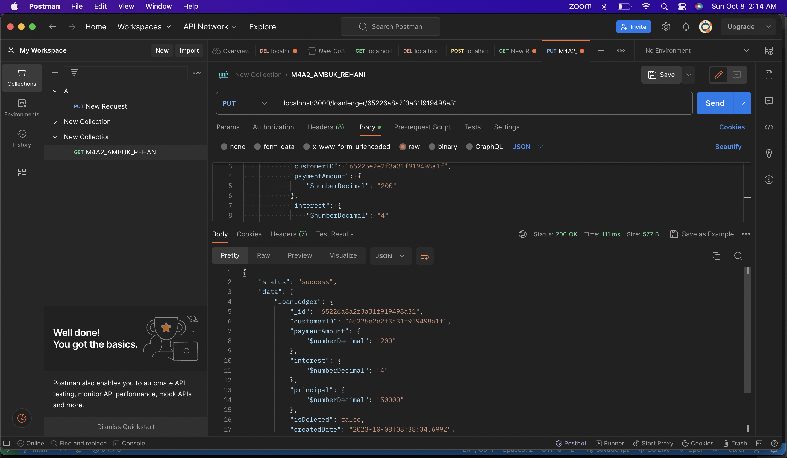

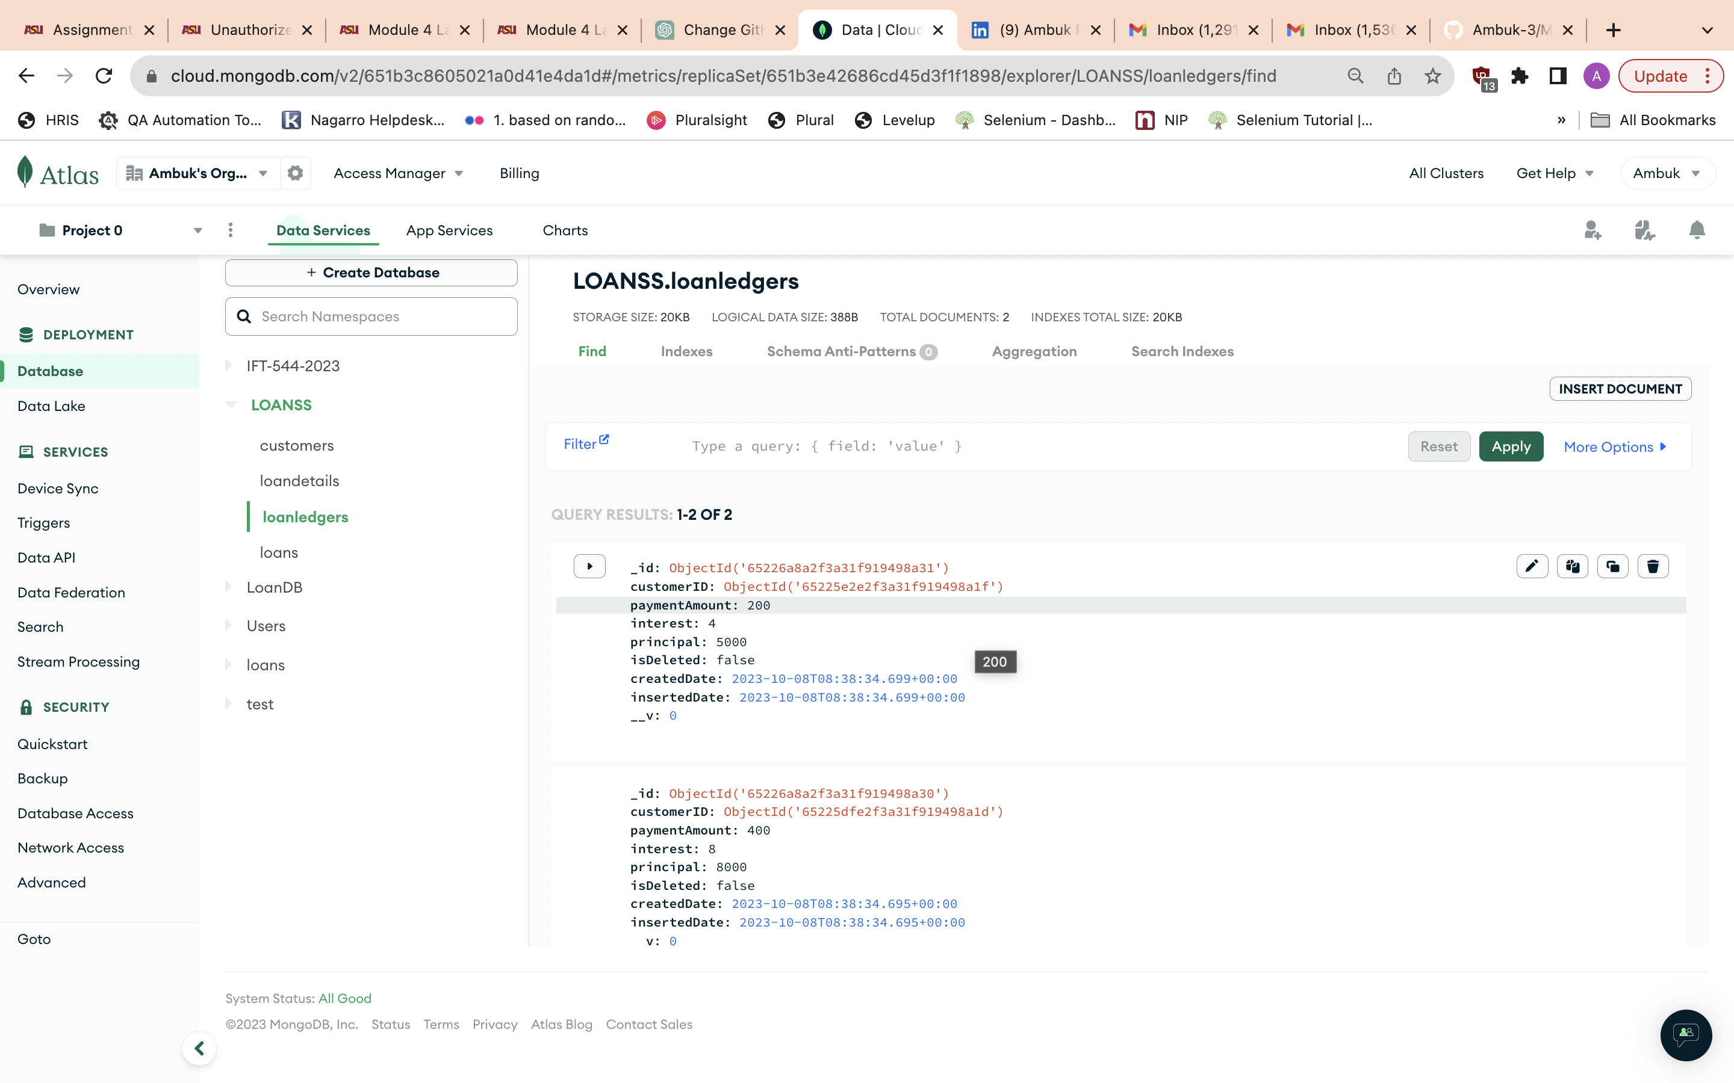

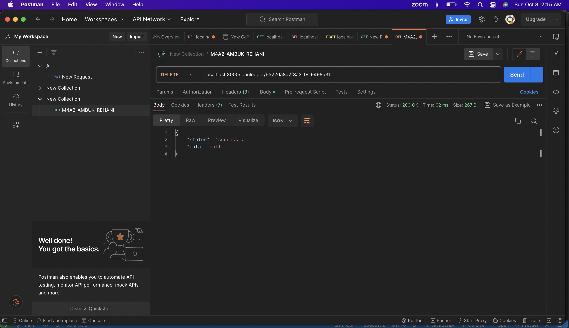

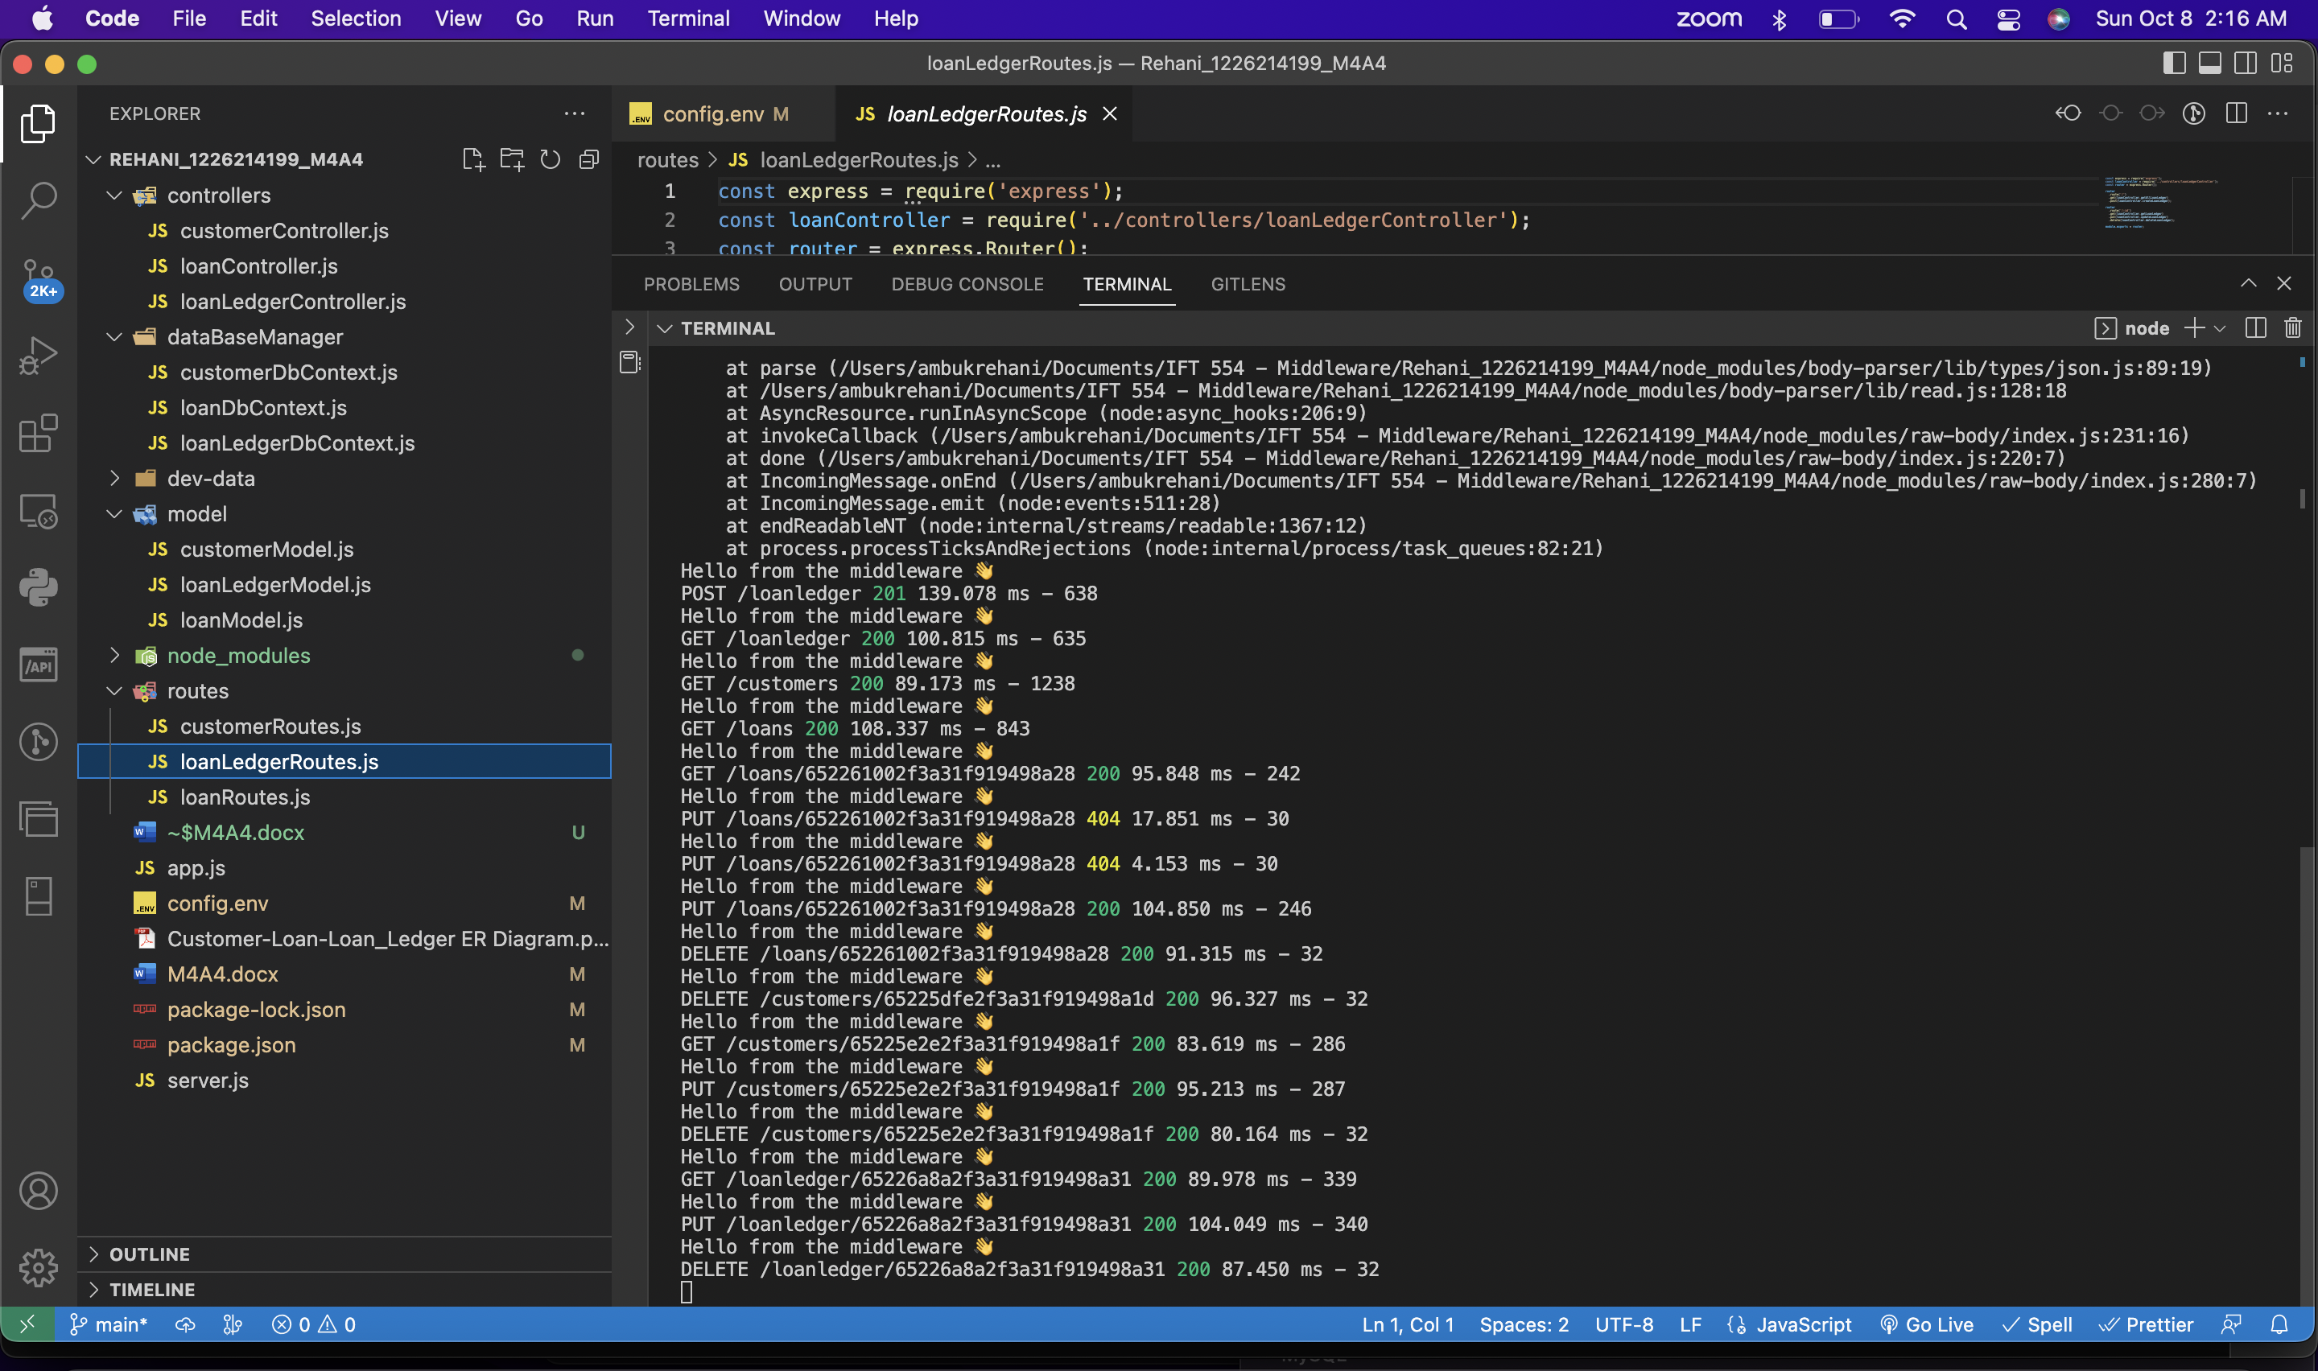

APIs:  
  
POST /customers This API endpoint facilitates the storage of customer information within the customer collection.

GET /customers This endpoint retrieves information pertaining to all customers from the customer collection.

POST /loans This API allows for the input and storage of loan data within the loans collection.

GET /loans This endpoint fetches information regarding all loans contained within the loans collection.

POST /loanledger This API enables the recording of customer payment data for loan repayments, storing the information in the loanledger collection.

GET /loanledger This endpoint retrieves data about all entries housed within the loanledger collection.

The aforementioned APIs are delivered using Express. These APIs manage data through controllers, and utilize Mongoose to validate, as well as facilitate the storage and retrieval of data within a MongoDB database.

Top of Form

Bottom of Form